**Sustainable Management of Guyana’s Seabob (*Xiphopenaeus kroyeri.*) Trawl Fishery**

Seion Adika Richardson

Ministry of Agriculture; Fisheries Department

Co-operative Republic of Guyana

[seion_richardson2000@yahoo.com](mailto:seion_richardson2000@yahoo.com)

Supervisors:

Dr. Pamela J. Woods

Dr. Ingibjörg G. Jónsdóttir

Marine and Freshwater Research Institute

Iceland

[pamela.woods@hafogvatn.is](mailto:pamela.woods@hafogvatn.is)

[ingibjorg.g.jonsdottir@hafogvatn.is](mailto:ingibjorg.g.jonsdottir@hafogvatn.is)

**ABSTRACT**

Seabob (*Xiphopenaeus kroyeri*) is the most heavily exploited shrimp species in Guyana and the largest seafood exported. This species is mostly caught by seabob trawlers, sometimes with large quantities of bycatch. The goal of this paper is to promote the long-term sustainability of marine stocks impacted by this fishery, by analyzing 1) shrimp stock status, 2) the current state of knowledge regarding bycatch impacts, and 3) spatial fishing patterns of seabob trawlers. To address the first, the paper discusses a stock assessment on Guyana`s seabob stock using the Stochastic Surplus Production Model in Continuous-Time (SPiCT). The model output suggests that the stock is currently in an overfished state, i.e., that the predicted Absolute Stock Biomass (Bt) for 2018 is four times smaller than the Biomass which yields Maximum Sustainable Yield at equilibrium (BMSY) and the current fishing mortality (Ft) is six times above the required to achieve Fishing Mortality which results in Maximum Sustainable Yield at equilibrium (FMSY). These results indicate a more overfished state than that generated by the previous stock assessment which concluded that the stock was fully exploited but not overfished (Medley, 2013).To address the second goal, the study linked catch and effort data with spatial Vessel Monitoring System (VMS) data to analyse the mixture of target and non-target species within the seabob fishery. The analysis found that of the five most common species in the bycatch, three are juveniles of species of economic value. Seabob biological data analysis found that the mean size of seabobhas gradually reduced when assessed between the years 2008-2018. Recommendations for fishery improvements include i.a. further capacity building in the understanding and application of appropriate stock assessment models for local experts, institute data quality measures, utilisation of a database, current data collections continue with improvements and decreases in seabob sizes and high presence of economically valuable species in bycatch are investigated.

**TABLE OF CONTENTS**

1 INTRODUCTION 1

1.1 Main goal of the study 3

1.2 Objectives of the study 3

1.3 Rationale 3

2 LITERATURE REVIEW 4

2.1 Species biology and distribution 4

2.2 Global history 5

2.3 Guyana’s seabob fishery 5

2.3.1 Stock status 5

2.3.2 Fishing fleet 6

2.3.3 Fishing zone 6

2.4 Fishing gear 7

2.5 Harvest control rule 8

2.5.1 Post HCR catch rates 8

3 MATERIALS AND METHODS 9

3.1 Data 9

3.1.1 Seabob data 9

3.1.2 Bycatch data 9

3.1.1 Spatial data 9

3.2 Data analyses 10

3.2.1 Creation of a biomass index from catch per unit effort data 10

3.2.2 Stock assessment using the surplus production model SPiCT 10

3.2.3 Changes in size distribution over time 12

3.2.4 Spatial analysis of fishing effort 13

3.2.1 Analysis of last haul bycatch 13

4 RESULTS 14

4.1 Creation of a biomass index from catch per unit effort data 14

4.1.1 Preliminary plots 14

4.1.2 GLM Best-fit model 17

4.1.3 Biomass index 17

4.2 Stock assessment using the surplus production model SPiCT 18

4.3 Changes in size distribution over time 20

4.4 Spatial analysis of fishing effort 22

4.5 Analysis of last haul bycatch 23

4.5.1 Haul composition 23

4.5.2 Bycatch composition 24

4.5.3 Species selection and mapping 28

5 DISCUSSION 32

5.1 Stock status and future considerations 32

5.2 Bycatch and its implications for management 34

5.3 Data used, challenges and improvements 35

6 CONCLUSION 36

7 RECOMMENDATIONS 37

8 ACKNOWLEDGEMENTS 38

9 REFERENCES 39

10 APPENDICES 42

Appendix 1 Procedure for adjusting HCR 42

Appendix 2 Weight (g) distribution for seabob (2008 - 2017) 43

Appendix 3 Global seabob landings (2000-2014) 44

Appendix 4 Length distributions of last haul species by category. 45

Appendix 5 Diagnostic plots from GLM 46

Appendix 6 Photos of species sampled in last haul 47

**LIST OF TABLES**

Table 1. HCR Index Reference Points used in developing a precautionary HCR. Reproduced from Medley (2014). 8

Table 2. Deterministic reference points: 18

Table 3. Predictions (95% CI): 18

Table 4. Results obtained from the Kolmogorov-Smirnov (K-S) Test (seen in Figure 13) 20

Table 5. Trips weights for seabob and bycatch, bycatch % and bycatch species count. 24

Table 6. Categorisation of bycatch species in the 25 last haul samples. Where n = the number of trips where species were present. 25

Table 7. Trip identification number, haul date, species, biomass data, fishing speed and number of observations (n) used to create bycatch maps. 28

Table 8. Global Capture Production (Tonnes) for Species (FAO, 2017) 44

**LIST OF FIGURES**

Figure 1. Distribution of the seabob shrimp along the coasts of the Americas (dark grey) and the respective landings by country. Reproduced from (Torrez, 2015). 1

Figure 2. Life cycle of a penaeid shrimp. Reproduced from Willems (2016 and references therein). 4

Figure 3. Global Capture Production (Tonnes) for Species (FAO, 2017) 5

Figure 4. Fishing mortality as a proportion of the estimated fishing mortality at MSY. Reproduced from (Medley, 2013). 6

Figure 5. Seabob trawling zone (7 and 18-fathom lines) within the EEZ. Reproduced from (Maison, 2015) 7

Figure 6. A bottom otter-trawl is a cone-shaped net comprising of a body which is closed by a codend and with adjacent wings spreading forward from the opening. The otter-trawl is kept open by two otter boards. Modified from Willems (2016 and references therein). 7

Figure 7. Seabob catch (A) and effort (B) observations as inputs for fitting SPiCT model. 11

Figure 8. Smoothed spline plots of mean seabob CPUE (A) and catch (B) as a function of month between January to December (2001-2018). 14

Figure 9. Smoothed spline plots of mean seabob cpue (A) and catch (B) as a function of days-at-sea between January to December (2001-2018) 15

Figure 10. Smoothed spline plots of mean seabob CPUE (A) and catch (B) as a function of fuel usage (litres) between January to December (2001-2018) 16

Figure 11 **–** Extracted biomass index used in the stock assessment 18

Figure 12. SPiCT estimates of (A) absolute biomass and (B) absolute fishing mortality time histories (2001 – 2018) assuming the generalised production model. The solid lines (blue) indicate the respective average biomass and fishing mortality, the shaded areas indicate 95% confidence intervals (CI). The Absolute Stock Biomass (Bt)is on the left side y-axis (A) and relative stock biomass (Bt/BMSY) is on the right side of the y-axis (A), with the 95% CI being between the dotted lines for Bt and between the shaded region for Bt/BMSY. Absolute fishing mortality (Ft)is on the left side y-axis (B) and relative fishing mortality (Ft/FMSY) is on the right side of the y-axis (B). The differently coloured points are fishing effort by months. The solid lines (blue) indicate the respective average biomass and fishing mortality, the shaded areas indicate 95% confidence intervals (CI). The horizontal solid lines denote the fishery reference point, that is, relative stock biomass at MSY (Bt/BMSY) in (A) and relative fishing mortality at MSY (Ft/FMSY) in (B). The fitted time series with a 2-year forecast and the beginning of the prediction time series is outlined by the upright grey line. 19

Figure 13. Empirical cumulative distribution function for seabob sampled between 2007 - 2018. 20

Figure 14. Smoothed distribution of seabob tail weights (g) sampled from January through? December (2008-2018). The lines on the plot represent the mean (red = 2.7g) and median (blue = 2.6 g) values. The orange dashed represents the median weight observed in sample each year, while the mean is shown in green and n = tail weight sample count. 21

Figure 15. Relative seabob tail weight (g) distribution of individuals sampled from January through December (2008 - 2018) 21

[Figure 16. Density map of fishing effort within Guyana’s EEZ for 2015 (A), 2016 (B), 2017 (C) and 2015-2017 (ABC). The inner cone-shaped boundary lines illustrate the seabob fishing zone (i.e. 7 and 18-fathom lines) beyond which seabob vessels are not permitted to trawl by law. The applied colour scale i.e. dark to light represents the different trawling intensities. The black/purple highlighted represents the areas “most fished” or the cumulation of satellite pings over time. 22](https://d.docs.live.net/02d6cda952b1c230/Documents/unu_final_draft_5.docx#_Toc2961255)

Figure 17. Proportion (%) of seabob to total bycatch by weights for all last trips. 23

Figure 18. Proportional representation of the most common bycatch species in last haul data by biomass. Bangamary (17%), seatrout (11%) and butterfish (8%) were species of commercial importance to Guyana and are target species for the artisanal fishery. These were 5% of the total species sampled, however they were responsible for 36% percent of the total sampled biomass. 27

Figure 19. Length frequency distribution of the three most common commercially important bycatch species caught in last haul. Where n = number of individuals measured. 27

Figure 20. Distribution of the seabob and bangamary caught in the last haul between 2015 and 2017. The conically shaped lines which enclose the catch are the inner and out boundary lines, i.e. 7 and 18-fathom lines, respectively. Where plot labels A = 2015, B = 2016 and C = 2017. The paired boxes with similar colour represent a single trip with the numbers being the catch weights (kg) of seabob and bangamary. The larger of the two numbers was always seabob. Where there is a single box, no bangamary was recorded in the catch. In order of left to right from on plots (numbers = trip identification number); Plot A; green = 3, Plot B; red = 10 , black (double) = 9, black (single) = 17, blue = 5, green = 11 and Plot C; green = 19, pink = 22, blue = 20. 29

Figure 21. Distribution of the seabob and butterfish caught in the last haul between 2015 and2017. The conically shaped lines which enclose the catch are the inner and out boundary lines, i.e. 7 and 18-fathom lines, respectively. Where plot labels A = 2015, B = 2016 and C = 2017. The paired boxes with similar colour represent a single trip with the numbers being the catch weights (kg) of seabob and butterfish. The larger of the two numbers was always seabob. Where there is a single box, no butterfish was recorded in the catch; 0 represents butterfish < 0.5 kg. In order of left to right from on plots (numbers = trip identification number); Plot A; green = 3, Plot B; red = 10 , black (double) = 9, black (single) = 17, blue = 5, green = 11 and Plot C; green = 19, pink = 22, blue = 20. 30

Figure 22. Distribution of the seabob and seatrout caught in the last haul between 2015-2017. The conically shaped lines which enclose the catch are the inner and out boundary lines, i.e. 7 and 18-fathom lines, respectively. Where plot labels A = 2015, B = 2016 and C = 2017. The paired boxes with similar colour represent a single trip with the numbers being the catch weights (kg) of seabob and seatrout. The larger of the two numbers was always seabob. Where there is a single box, no seatrout was recorded; 0 represents seatrout < 0.5 kg. In order of left to right from on plots (numbers = trip identification number); Plot A; green = 3, Plot B; red = 10 , black (double) = 9, black (single) = 17, blue = 5, green = 11 and Plot C; green = 19, pink = 22, blue = 20. 31

Figure 23. Weight (g) distribution of seabob sampled between January to December (2008-2017). 43

Figure 24. Length (cm) distribution of commercial species most present in sample. 45

Figure 25. Length (cm) distribution of non-commercial species most present in sample 45

Figure 26. Diagnostic plots (residuals vs. fitted values and cumulative normalized residual plots) from GLM fitted seabob dataset. Factors considered were months, vessels, days at sea and fuel usage. In general, residual patterns are not far from expected under the normal error distribution assumption, which suggests a reasonably good fit. 46

**LIST OF ABBREVIATIONS**

Bt  - Absolute Stock Biomass

BMSY  - Biomass which yields Maximum Sustainable Yield at equilibrium

CEFAS - Centre for Environment, Fisheries and Aquaculture Science

CIs - Confidence Intervals

CPUE - Catch Per Unit Effort

CRFM - Caribbean Regional Fisheries Mechanism

ECDF - Empirical Cumulative Distribution Function

EEZ - Exclusive Economic Zone

FAO - Food and Agriculture Organisation

FMSY  - Fishing Mortality which results in Maximum Sustainable Yield at equilibrium

Ft - Absolute Fishing Mortality

GLM - Generalized Linear Model

GPS - Global Positioning System

HCR - Harvest Control Rule

MSC - Marine Stewardship Council

MSY - Maximum Sustainable Yield

P1 - Principle one

P2 - Principle two

P3 - Principle three

SWG - Seabob Working Group

TAE - Total Allowable Effort

USA - United States of America

VMS - Vessel Monitoring System

# INTRODUCTION

*Xiphopenaeus kroyeri*, commonly called the Atlantic seabob (hereafter referred to as seabob), is a commercially important shrimp species harvested in Guyana. The seabob fishery in Guyana started in excess of three decades ago, i.e. 1984 (Maison, 2015). From that time to present, the fishery has gradually increased capacity with regards to catches landed and total fishing effort (Maison, 2007). Seabob landings have shown a notable 15% increase recorded in 2016 when compared to the previous year (Fisheries Department, 2017). Relative to Trinidad and Tobago, Suriname, French Guiana, and Brazil, Guyana account for the largest proportion (Figure 1) of the global landings of seabob; with catches fluctuating from slightly below 15,000 to 25,000 tonnes during the years 2000 to 2016 (FAO, 2018).

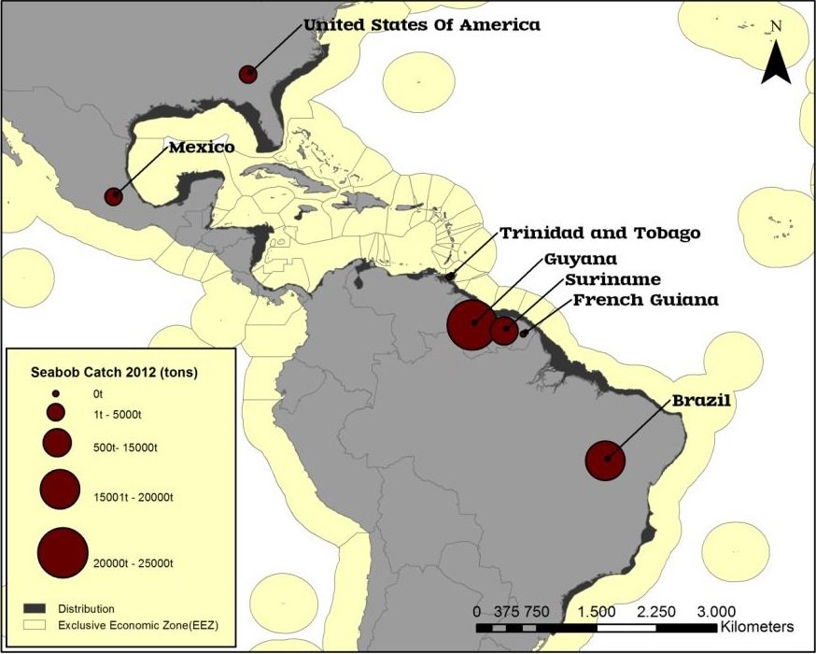

*Figure 1.* Distribution of theseabob shrimp along the coasts of the Americas (dark grey) and the respective landings by country. Reproduced from (Torrez, 2015).

Focusing its attention on the management needs of the fishery, the Seabob Working Group (SWG) formulated a work plan to bring the industry in alignment with Marine Stewardship Council (MSC) standards. Consequently, several interceptive measures were employed, one of which allowed for an updated stock assessment being done in June 2013 by the Caribbean Regional Fisheries Mechanism (CRFM). In the said year, a new Fisheries Management Plan (2013-2018) was drafted to guide management of Guyana’s Fisheries, in accordance with standing regulations. The plan had the following objectives for seabob management; (a) to sustain theseabob stock and all non-target species which interact with the fishery above 50% of their mean unexploited biomasses (b) to steady the net earnings of the fishery operators above the local minimum desired income (c) “to include as many of the existing participants in the fishery as is possible; given the biological, ecological, and economic objectives (CRFM 2012)” (Sustainable Fisheries Partnership, 2018).

With a view toward safeguarding seafood supplies for the future, Guyana has recently entered MSC assessment for certification of its seabob fishery, and as such, it is pertinent that the said fishery aligns its operational standards, as well as its management practices with the prerequisites for the desired certification and long-term sustainability. The country’s pursuance of this certification dates back to 2008/2009 (Carleton, 2017). Some of the needs highlighted from a recent evaluation of whether the fishery met such standards include: strengthening of government/industry capacity to manage these fisheries, a concerted move toward evidence-based fisheries management, and pursuance of an adaptive management regime and cost-effective research (Carleton, 2017). The recent entry of the fishery into MSC assessment (October 2018) will see the fishery being assessed under three main principles: sustainable utilization of fish stocks (Principle one (P1)), minimising environmental impacts (Principle two (P2)) and fisheries management (Principle three (P3)) (Willems, 2018). P1 of the MSC requirement focuses on the management of the target stock. P2 covers fishing operations and minimizing interaction with other species outside of the target stock. The structure, productivity, function and, diversity of the ecosystem upon which the fishery depends should be considered in management, including the maintenance of other species and habitats. Lastly, P3 focuses on having the fishery meet all local, national and international laws and having an effective management system in place (Santos, 2018).

The seabob fishery operating offshore Guyana is like Suriname`s in terms of vessel and gear technology (Willems, 2018), however, the two fisheries are harvesting different stocks (CRFM, 2014). The fisheries are different in that Guyana has a larger fleet size and the vessels can fish in shallower waters: there is an upper limit of 7 fathoms as opposed to 10 fathoms in Suriname (Willems, 2018). Nevertheless, the marine ecosystems are believed to be similar, with the continental shelf of both countries is part of the Guianan Ecoregion of the North Brazil Shelf ecosystem (Willems, 2018). There has been recent research on the ecological effects on habitats and ecosystems of the seabob trawling in both countries, with consideration for fulfilling this requirement under P2 of the MSC certification guidelines. From these studies, the findings indicate that the communities of demersal fish were diverse and may be affected as bycatch from the fishery (Willems, 2018). In Guyana, it is believed that the seabob trawl fishery has high levels of bycatch, most of which are juvenile finfish (Gascoigne, 2013). Willems (2018) found that the length frequency distributions for the most common fish species included juvenile stages of larger and commercially important fish species such as *Nebris microps* (butterfish), *Macrodon ancylodon* (bangamary) and *Cynoscion virescens* (seatrout). Anecdotal reports from consultations with fishermen have revealed the juvenile bycatch species are usually discarded with the marketable sizes being landed. Said sources also suggested that total discards of small fish and non-marketable species such as stingrays are considerable (Gascoigne, 2013). Finfish are typically regarded as bycatch; however, trawlers may target fish when catch rates for seabob are low to cover trip expenses (Gascoigne, 2013). In addition, “there is the concern in the Fisheries Department that trawling for finfish may increase in the future” (p. 14, (Gascoigne, 2013)).

Against this backdrop, this study attempts to generate information on the stock status of seabob using an alternative assessment model than the one currently used and investigate the distribution of bycatch and fishing effort within the fishery. Such analyses will complement work done thus far while highlighting key areas for development. These potentially feed directly into target-specific strategies which in turn improve policy development and resource management. The prelude to achieving objectives of the seabob management plan is directly linked to having trained personnel on the ground, with the requisite skills of conducting appropriate stock analysis and assessments, as well as analyses of bycatch component of the catch.

## Main goal of the study

The main goal of this study is to conduct analyses on the seabob and bycatch from Guyana`s seabob fishery by looking at the relative composition and distribution within the established fishing zone. The research will be done utilizing the catch and effort logbook data joined with spatial data from the vessel monitoring system. The results obtained, and the experience garnered from this study will be used to recommend avenues for improvement in the management of Guyana`s seabob trawl fishery.

## Objectives of the study

1. To conduct an assessment on Guyana`sseabob stock to determine the species current status and compare with alternative assessments using catch and effort data from 2000 to 2017 as well as size distribution data from 2007 to 2018.
2. To determine trends, intensity and spatial distribution of bycatch species caught by theseabob fleet using spatial Vessel Monitoring System (VMS) data from 2015 to 2017.
3. To define management recommendations in accordance with current gaps in data collection or management practices identified by this study.

## Rationale

The first objective of this study contributes to management objective A (sustain the seabob stock) of the seabob management plan by providing an alternative assessment of theseabob stock. Although there is a stock assessment available for seabob, conducting an alternative one is useful because conclusions from the first suggested a high level of uncertainty. It also promotes capacity building of fisheries management staff in Guyana which will over time reduce the cost attached to outsourcing experts. Additionally, the lack of local specialists in the past resulted in many stocks being unassessed for lengthy periods and poor stock management; resulting in overfishing and consequent stock collapse in instances.

The second objective contributes to management objective C (bycatch management and retaining participants) of the seabob management plan because it will analyse species composition of bycatch which may be of importance to stock sustainability and job security in other fisheries. A proportion of seabob bycatch is made up of juveniles of commercially important species, which could contribute to recruitment overfishing of those stock. Additionally, the country’s chances of acquiring and maintaining MSC certification is dependent on proper management of this component of the catch. Also, noteworthy is that being able to assess bycatch stocks can also help with obtaining and sustaining MSC certification.

Lastly, the third objective will highlight key areas for improvements of the seabob fishery management, which can guide appropriate actions such as considerations for closed areas and temporal zoning, thereby contributing to both management objectives A and C by clearly establishing possible means for addressing many of the gaps and challenges encountered during the analyses.

# LITERATURE REVIEW

## Species biology and distribution

The distribution of the seabob shrimp species is spread along the coasts of the Western Atlantic Ocean, spanning from North Carolina in the USA to Santa Catarina State in South Brazil (Holthuis, 1980). This crustacean species is usually found in high abundance in shallow waters (< 30 m), making it easily accessible for coastal fisheries (Holthuis, 1980). Research studies have found that seabob dwell in both marine and brackish water habitats, occurring in depths reaching 70 m, but predominantly within shallow waters of less than 27 m deep (Holthuis, 1980). A survey off Brazil found that species reproduction is said to take place throughout the year, however, with two peaks of intensity (Paiva, 1996). The juvenile population favours less saline (brackish) waters, using estuarine or inshore coastal waters as nursery grounds. The species undergoes several developmental changes throughout its life cycle (Figure 2); most of which occur offshore, with the postlarvae and juvenile stages occurring in estuarine environments where there is lower salinity (Willems, 2018). The species migrates both during the early stages of development, i.e. larvae and post-larvae stages, and as adults, when migration occurs between shallower feeding grounds to allow for growth and greater depths to allow for spawning (Dall, Hill, Rothlisberg, & Sharples, 1990).

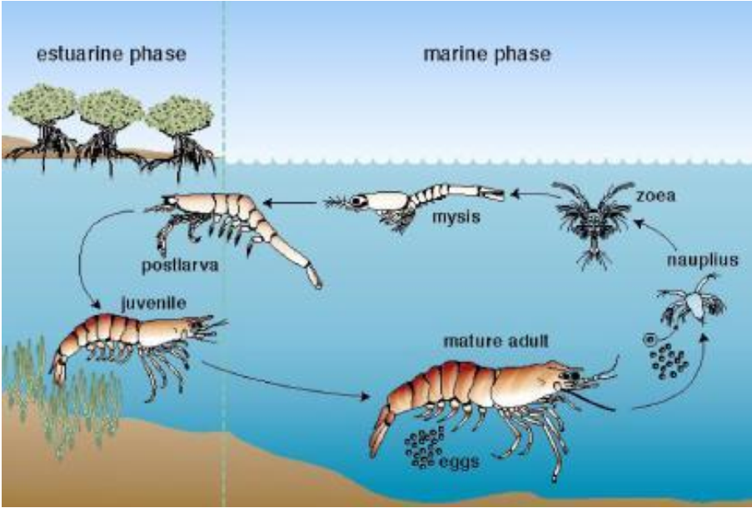

Figure 2. Life cycle of a penaeid shrimp. Reproduced from Willems (2016 and references therein).

Species demographic differences and nursery habitats are progressively perceived as important to conservation management of marine ecosystems globally. There can be differences in the levels of tolerance to salinity amongst populations of the same species depending on their geographical origin, and according to their different stages of life (Péqueux, 1995). Willems (2016) noted that seabob can obtain a total length of 10 cm (Holthuis, 1980) in a relatively short period of time. The males are smaller than the females, with an average life span of 1.5 years while the average female lives approximately three months longer (Willems, 2016 and references therein). Despite an increase in research conducted on the species recently, there is limited understanding of the species demography and morphology (Willems, 2016).

## Global history

Global catches of seabob have shown an increasing trend (Figure 3). Seabobhas at times been by far the most significant commercial species in the region of the United States from Pensacola (N.W. Florida) to Texas with yearly recorded catches of 2,100 - 3,182 t between 1973 to 1975 (FAO, 2017). Guyana, Brazil and, Suriname are amongst the largest harvesters ofseabob (Figure 1). The species is also harvested in Mexico periodically where it is not of commercial significance, with concentrations also off eastern Venezuela and Trinidad (FAO, 2016 and references therein). Other cited fishing grounds for this species include Honduras, Nicaragua, Costa Rica, Colombia. The species is deemed “the most common commercial shrimp in local fisheries” (FAO, 2016 and references therein). It is usually harvested by local fishermen and marketed fresh, dried, or frozen (FAO, 2016 and references therein).

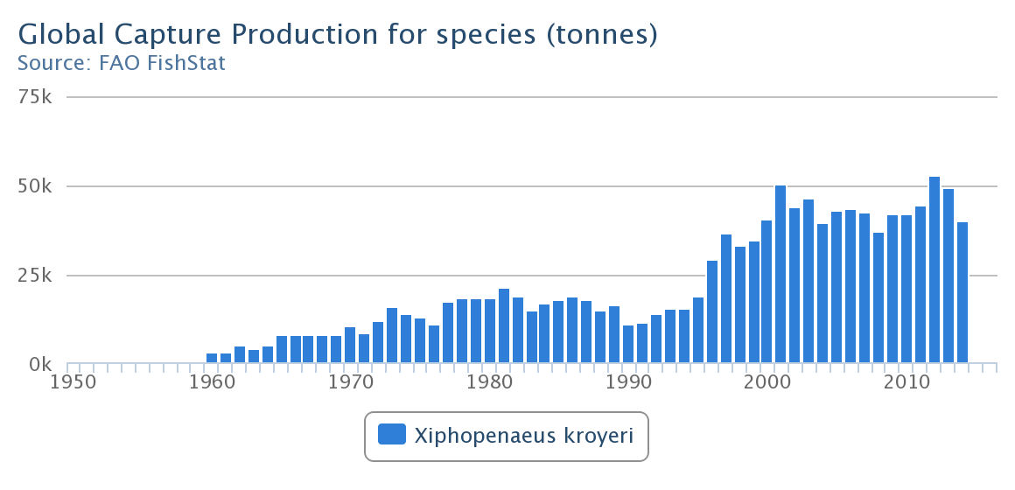

Figure 3. Global Capture Production (Tonnes) for Species[1] (FAO, 2017)

## Guyana’s seabob fishery

### Stock status

Following the stock’s most recent assessment in June 2013, Guyana`sseabob could be best described as fully exploited but not overfished (Medley, 2014). Medley further stated that the stock is close to a default precautionary target level and can be considered “fully exploited” (Figure 4). The results obtained from the stock assessment highlighted that in earlier years the stock was overfished and was at greater risk of becoming overexploited (Medley, 2014). This occurrence, however, was infrequent, as fishing mortality has only rarely exceeded fishing mortality at Maximum Sustainable Yield (MSY), so overfishing has rarely taken place (Medley, 2014). Nevertheless, the stock assessment did highlight uncertainties, for example, Fishing Mortality which results in Maximum Sustainable Yield at equilibrium (FMSY) was poorly estimated and depended on a parameter in the stock-recruitment relationship, which had to be assumed (Medley, 2014). Against this reality, Medley (2014) concluded that the result attained should represent an upper limit until more information on appropriate fishing mortality can be obtained and an appropriate MSY based reference point for fishing mortality remains to decided (Medley, 2014).

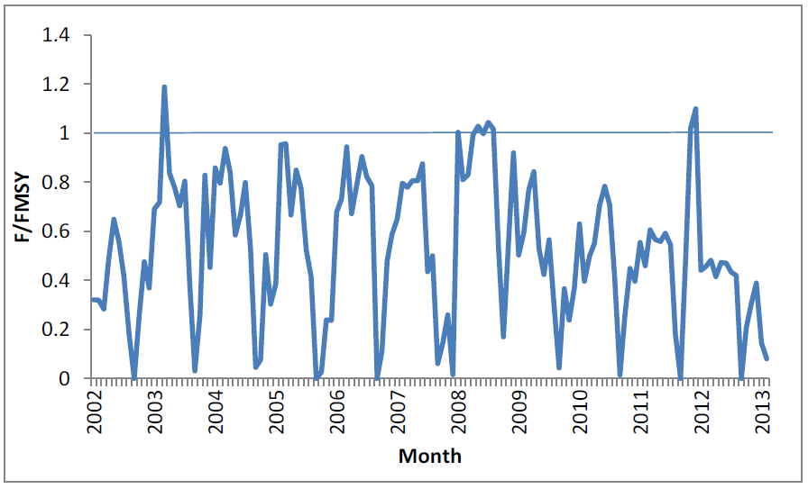

*Figure 4*. Fishing mortality as a proportion of the estimated fishing mortality at MSY. Reproduced from (Medley, 2013).

### Fishing fleet

Guyana`s industrialseabob fleet is comprised of 87 `Florida-type` twin outrigger trawler/fishing vessels (Maison, 2015). Theseabob trawlers are mandated by legislation to fish between a maritime coordinated zone of 7 and 18-fathoms water depth along Guyana’s coastline within the Exclusive Economic Zone (EEZ). The vessels are equipped with relatively modern technology, which includes but is not limited to Global Positioning Systems (GPS), VMS, Turtle Excluder Devices (TED) and Bycatch Reduction Devices (BRD) (Maison, 2015). The vessels are non-refrigerated, hence their days spent at sea are influenced by chilling capabilities and rate of harvest, among other factors (Maison, 2015).

### Fishing zone

The data utilised in this study were sourced within the EEZ of the Co-operative Republic of Guyana formerly known as British Guiana, bordered by the Atlantic Ocean to the north, Suriname to the east, Venezuela to the west and Brazil to the south and southwest. The boundaries of the country`s Exclusive Economic Zone (EEZ) delimits approximately 136,000 km2 (MacDonald, Harper, Booth, & Zeller, 2015). Seabob trawling occurs off Guyana`s coastline where all fishing vessels are mandated to operate between 7 and 18-fathom lines[2], respectively (Figure 5).

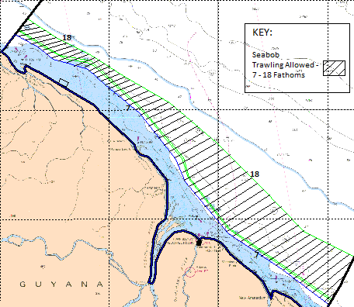

Figure 5. Seabob trawling zone (7 and 18-fathom lines) within the EEZ. Reproduced from (Maison, 2015)

## Fishing gear

The bottom trawl used by theseabob trawls is conical net bags with an extensive mouth, fitted with weights and floats on the ground and head ropes, respectively (Figure 6). When deployed and trawling, the net is kept opened by two wooden otter boards which are towed by the warps and are connected to the nets by bridles. The nets are on average 13.5 m in length and are used to sweep the seabed over an extended area during 4-hr spans.

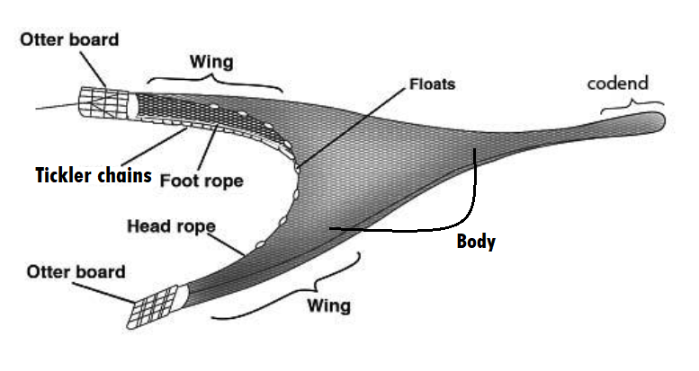

Figure 6. A bottom otter-trawl is a cone-shaped net comprising of a body which is closed by a codend and with adjacent wings spreading forward from the opening. The otter-trawl is kept open by two otter boards. Modified from Willems (2016 and references therein).

The local (Guyana)seabob trawler vessels use nets with mesh sizes of roughly 60 mm in the body and wings of the trawl, and 45 mm in the codend. The codend of the net is the single most selective area and is usually where the shrimps and bycatch are trapped. The shrimp are startled at the presence of the nets, resulting in them moving involuntarily into the path of the net opening and ultimately being captured. The nets are conical in shape and aligned at the bottom with tickler chains, which also adds to the efficiency of the gear, as it causes the species to move directly into the trajectory of the net (Sparre & Venema, 1998).

## Harvest control rule

Following the stock assessment done in 2013, the seabob fishery, from the year 2015 to present is being managed by a Harvest Control Rule (HCR), which allows for a maximum of 87 vessel licenses to fish seabob and a maximum 225 days at sea per licenced vessel when the catch index is at or above the target index (Medley, 2014). The rule outlines a procedure[3] for adjusting fishing days relative to the current observed catch index which can be best described as an average between the previous year’s index value and the catch rate of the previous year (i.e. a moving average) (Medley, 2014). The catch rate is based on reported catch and effort data for all vessels. The target, trigger and limit reference points would be roughly 19,000 lb, 17,000 lb and 10,000 lb (Table 1) of whole seabob biomass per trip (i.e., 600 kg, 540 kg, 315 kg, respectively, of processed tail weight) per standardised day-at-sea (Appendix 1). A value of 19,000 lb/trip (or above) would signify a target catch rate, while 10,000 lb/trip signifies the limit, beneath which the fishery should, as far as possible, be closed. The value 17,000 lb/trip signifies the trigger point, where directors would intervene and consider appropriate actions such as a fishing closure to replenish the stock (Medley, 2014).

Table 1. HCR Index Reference Points used in developing a precautionary HCR. Reproduced from Medley (2014).

|  |  |  |
| --- | --- | --- |
|  | Index Value (kilograms processed tail weight per standardised day at sea) | Equivalent per trip landings Approx. pounds whole weight per average trip) |
| Target Reference Point (TRP) | 600 | 19000 |
| Alternative TRP | 630 | 20000 |
| Trigger Point (TP) | 540 | 17000 |
| Limit Reference Point (LRP) | 315 | 10000 |

### Post HCR catch rates

The initial calculations conducted found that the CPUE for 2015 was 596 kg/sdas; which translated to 224 DAS per vessel. This was enforced at the time (i.e. for 2016). However, following a subsequent review of the data, amendments were made and the CPUE fell further to 583 kg/sdas. As a result, the total fishing days allowed in 2016 was reduced by 1 day for every fishing vessel i.e. a revised 224 per vessel (Appendix 1). In 2016 and 2017 the observed CPUE was considered satisfactory, as is reflected in the annual catch rates of 649 and 715 kg/sdas; both above the TRP. This meant that the CPUE in 2017 increased by 10% (66 kg/sdas).

# MATERIALS AND METHODS

## Data

The Fisheries Department of the Ministry of Agriculture is the organisation which collects, compiles and analyses fisheries data,seabob included. Data from the seabob fishery are usually submitted by the processors and collected by departmental staff as part of a random catch sampling programme. Data submission and collection has been an important feature throughout the existence of the seabob fishery with the stratified random sampling programme being last updated by Mahon (1998). The stratification is done by vessel/gear type and each month the number of vessels to be sampled for each gear is pre-defined (Mahon, 1998). The programme was recently reviewed by the Centre for Environment, Fisheries and, Aquaculture Science (CEFAS) and it was concluded that the current sampling had good technical coverage (Santos, 2018). In recent years, there has also been a collection of spatial data via the VMS which is housed at the Fisheries Department. The data types used in this study are discussed in the subsections below.

### Seabob data

This dataset is comprised of monthly catch landings and effort data (i.e. days at sea, fuel usage, years, months and vessels) and extends from 2001 - 2018. The primary data source is log sheets which were submitted by the processors and random samples of unpeeled tail weights collected 2006 – 2017.

### Bycatch data

Bycatch data were generated over a period of three years (2015-2018) from the last haul programme, carried out by the department with support from WWF, includingseabob fishing vessels from the fishery. The programme consisted of random fishing vessels (at least two each month) landing the total catch to be sorted and weighed to species level. Length measurements[4] were only recorded for species samples that were in excess of 30 individuals, the minimum required for plotting purposes (T. Willems, pers. comm.). Over time, 40 last haul trips were conducted. Of this amount, 63% (25) trips were without critical data gaps, so were possible to use in the analysis. A proportion 68% (17 trips) of said trips had an observer present onboard, which improves the overall credibility of the data.

### Spatial data

Spatial data (2015 to 2017) of fishing trips including vessel co-ordinates and fishing speeds, were obtained from VMS. The VMS is a satellite-based surveillance technology which is used in fisheries globally to monitor the movement of licensed fishing vessels.

## Data analyses

### Creation of a biomass index from catch per unit effort data

The biomass index for the assessment was analysed using a Generalised Linear Model (GLM). This method is used most frequently for Catch Per Unit Effort (CPUE) standardization where raw catch and effort data is used to estimate a year effect (Maunder & Langley, 2004). The purpose of standardisation is to fine-tune abundance indices to account for variation in the index that might be linked to catchability rather than variations in abundance, which apart from minimising the noise of the index possibly eliminates bias. The standardisation is also expected to eliminate noise associated with fishing power or methods, thereby clarifying abundance trends. Seabob trip-level CPUE data (2001-2018) (i.e. catch/days-at- sea) were modelled as the response variable using the explanatory variables of effort, years, months, vessels and fuel. In selecting the explanatory factors; an unsaturated model was fitted. This initial step was followed by conventional hypothesis testing to verify if adding each term, one at a time, resulted in a significant decrease in deviance. The interactions were tested first before dropping with the main effect of a factor being discarded only if all interactions that included that factor were already discarded. The model formula is as follows:

|  |  |  |
| --- | --- | --- |
|  |  | (1) |

Where the response variable is modelled by a linear function of explanatory variables, represented by plus an error term. Polynomial terms were also tested for select explanatory variables. The distribution used was the Gaussian, which has a constant variance function and a µ (identity) link function. The family choice was influenced by the normal distribution of the data used in the GLM. The variables contained continuous observations by fishing trips between 2001 to 2018. The biomass index was extracted from the model as predictions based on the sum of the coefficients estimated for the factor’s year, month, and the interaction between year and month.

### Stock assessment using the surplus production model SPiCT

The SPiCT model was fitted to theseabob catch and the extracted biomass index for the years 2001- 2018 using the SPiCT R package (Pedersen M. W., 2017) and by following steps documented by Pedersen and Berg (2018). Additionally, SPiCT generally requires very few variables for the assessment e.g. catch and effort or an index of biomass, which makes the model very applicable to shrimp fisheries that are predominantly data-deficient (Pedersen, Berg, & Kokkalis, 2018). Continuous time in the SPiCT formulation is modelled through a Euler time step scheme with a default time increment *dt*Euler equivalent to 1/16. Optimisation of the model fit was attained by means of log-likelihood functions. Post-processing code supplied by Pedersen and Berg (2017) was used to analyze the results of the model fit to input data shown in Figure 7.

The model was initially run with annual catch data along with the respective biomass indices generated from the GLM. When modelling these variables, the model fit was unable to estimate key parameters which resulted in the model not converging. This was corrected by two modifications. First, the model inputs were adjusted as recommended by Pedersen et al. (2018), i.e., by using effort data directly in the model instead of the commercial CPUE as an index. Fishing effort was calculated by dividing the biomass index by the catch weight data. Second, the model was fitted using subannual (monthly)seabob catch weight data and the effort data. Using subannual data improved the model convergence, likely due to the short life-span of the species, so that approximation of reference points relative to discrete-time analysis of combined yearly data (Pedersen & Berg, 2017).

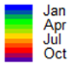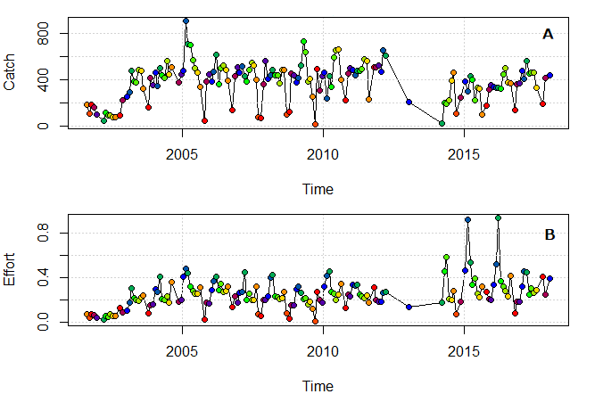

Figure 7. Seabob catch (A) and effort (B) observations as inputs for fitting SPiCT model.

### Changes in size distribution over time

Understanding species size distribution is an important component of fisheries management and can provide useful information on mean growth, relative to time. Seabob tail weights collected for the period 2008 – 2018 was used as an index of size. The data were analysed using the Empirical Cumulative Distribution Function (ECDF), adopted from Ogle (2016). The ECDF is a non-parametric estimator of the underlying ECDF of a random variable, which assigns a probability to each weight observation. This function is useful because in large sample sizes it allows for knowing the distribution which becomes helpful for making statistical inferences about the population. Additionally, ECDF plots can be generated (Figure 13) which allows for visual comparison of annual cumulative distribution frequency and the relative rate of increase/decrease (Cai, 2013). The ECDF is defined as follows:

|  |  |  |
| --- | --- | --- |
|  |  | (2) |

Where *I* () is the indicator function which has two possible values: 1 if the event inside the brackets occurs, and 0 if not.

|  |  |  |
| --- | --- | --- |
|  |  | (3) |

The function assigns a probability of 1/n to each datum orders the tail weights from smallest to largest and calculates the sum of the assigned probabilities up to and comprising each datum. This results in a step function that rises by 1/n at each datum (Cai, 2013).

Finally, the weight frequency analysis described above were compared using the Kolmogorov-Smirnov (KS) two-sample test (Neumann & Allen, 2007). The KS tests named after Andrey Kolmogorov and Nikolai Smirnov is used to analyse the distribution between two samples (Ogle, 2016). The test was applied here to determine whether theseabob tail weights between 2009 – 2018 were similar by quantifying the distance between the empirical distribution functions of the two reference years.

### Spatial analysis of fishing effort

The spatial analysis of fishing effort using VMS data has been widely practised by fisheries management authorities globally. Such analysis provides information to management on changes in long term fishing patterns and relative fishing pressures, which can guide appropriate management actions. This importance has been recognised by Guyana, who has since 2013 integrated VMS technology into the management of its seabob fishery. In Guyana, it has recently (2018) become a legal requirement for all licensed fishing vessels to be equipped with VMS. VMS data are collected using the Meta Fisheries Software (Mapping environment for tracking application), which is continually monitored by the Legal and Inspectorate Unit of the Fisheries Department (Amsterdam, 2017) and will be used in this analysis. This analysis will utilise data from 2015 - 2017 which comprises i.a. fishing: vessels, trip dates, speeds (0,3 knots) and latitude & longitude which will be used to generate informative maps comprised of different temporal fishing intensities. Altogether a total of 1,424,882 vessel positions will be mapped of the years 2015 - 2017.

Details of study area. Reproduced from Amsterdam (2017):

|  |  |
| --- | --- |
| **Country:** | Guyana |
| **Place type:** | EEZ |
| **Latitude:** | 8° 36' 53.3" N (8.61480859°) |
| **Longitude:** | 57° 40' 8.3" W (-57.66896753°) |
| **Precision:** | 371038 meters |
| **Min. Lat:** | 5° 29' 10" N (5.4861°) |
| **Min. Long:** | 59° 59' 25" W (-59.9903°) |
| **Max. Lat:** | 10° 41' 35.9" N (10.6933°) |
| **Max. Long:** | 55° 46' 32.7" W (-55.7758°) |

### Analysis of last haul bycatch

The sustainability of bottom trawl fisheries is dependent on the collection and analysis of data on bycatch. Such analysis will generate useful information on species composition within the total catch, which can be used to guide evidence-based fisheries management. For this analysis bycatch data collected from the last fishing haul of 25 trips between 2015 – 2018 from seabob trawl vessels were used, along with data from the VMS (see subsection 3.2.4). The data was generated from a programme in which these vessels landed the entire catch from the last fishing haul, following which the catches were sorted onshore to species level. The analysis focused on species classification, weight, and length observations and spatial distribution of the catches. To conduct this part of the analysis, the trip observations from the last haul were linked to the corresponding VMS observations. The keys used to link the data were the vessel names, departure and arrival dates (VMS), with the latitude and longitude fields being the key variables used for spatial referencing and plotting of points. For the purpose of the analysis, a proxy of vessel speed in the range (1, 3) knots was used to denote when the vessels were fishing.

# RESULTS

## Creation of a biomass index from catch per unit effort data

The explanatory variables (year, month, vessels, days at sea, fuel, the interaction year x month and polynomial fuel terms) were examined against the response variable CPUE (biomass/days-at-sea) before inclusion in the final model. Preliminary plots (subsection 4.1.1) were done to clearly visualise the data to check for any major inconsistencies and or abnormalities before using in the GLM.

### Preliminary plots

The monthly trend in mean CPUE and mean catch weight show a similar pattern (Figure 11). Both the CPUE (> 1,000 kg/month) and catch weights (> 8,000 kg/month) are higher in the first half of the year compared to latter half, when they were mostly below 1000 kg/month and 8,000 kg/month, respectively. The lowest CPUE was observed in August (995 kg) and the highest in March (1,250 kg). The lowest catch weights were observed in September (7,783 kg) and the highest in March (9,617 kg). The results from both plots highlight consistent variability in CPUE and catch weights across months.

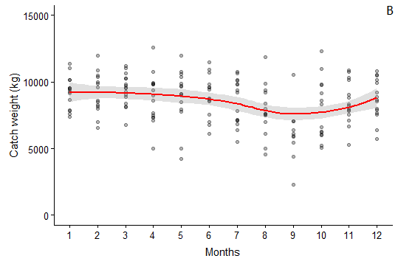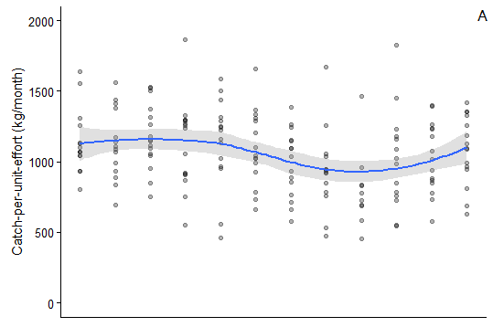

Figure 8. Smoothed spline plots of mean seabob CPUE (A) and catch (B) as a function of month between January to December (2001-2018).

An increase in days-at-sea has a more pronounced negative impact on mean CPUE than it does on catch weights (Figure 9). CPUE across days-at-sea shows a steady increase in catch up to 7 day-at-sea following which CPUE sharply reduces. There is also a steady increase in catch up until 7-9 days-at-sea, following which catch weights level out between 10-20 days at sea. The results from both plots highlight wider variations in CPUE and catch for trips over 12 days, partly because of fewer observations.

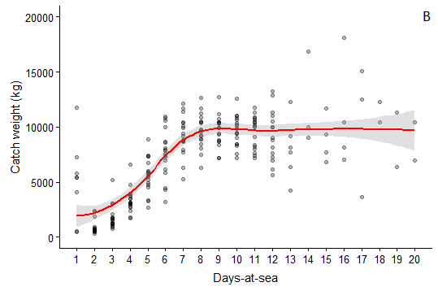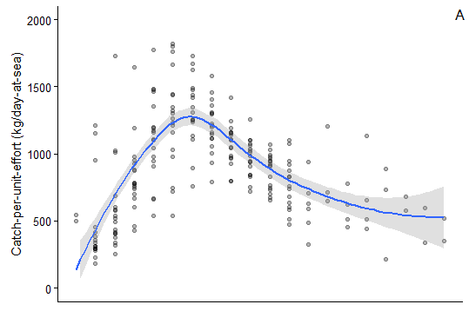

Figure 9. Smoothed spline plots of mean seabob cpue (A) and catch (B) as a function of days-at-sea between January to December (2001-2018)

There is a pronounced difference in trends seen in the plot of CPUE against fuel usage and that of catches against fuel usage (Figure 10). The plot of CPUE across fuel usage shows a gradual decrease with increased fuel usage, except for the trips that used ~5,000 litres of fuel. Conversely, catch weights increases steadily with increased fuel usage.

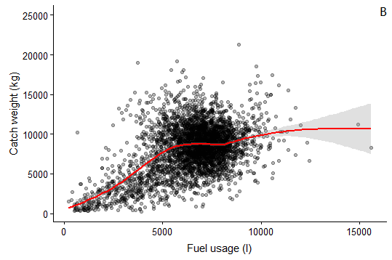 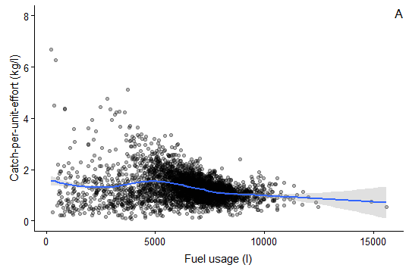

Figure 10. Smoothed spline plots of mean seabob CPUE (A) and catch (B) as a function of fuel usage (litres) between January to December (2001-2018)

### GLM Best-fit model

In the final model selected, both days at sea and fuel usage had a positive effect on theseabob biomass. The results also demonstrated that the monthly CPUEs were significantly different from January CPUE (p < 0.05) for all months except April and May, while the coefficients for days at sea and fuel usage were also significant. The results of diagnostic plots suggested that no assumptions were significantly violated. The plots of predicted values and residuals revealed no pattern except that the residuals were more broadly distributed in the middle range of the catch data. The Normal -QQ plot indicated that residuals were distributed as expected from a normal distribution, i.e. many points are close to the predicted values given by the dotted line (Appendix 5).

|  |  |  |  |  |  |  |  |  |  |  |  |  |  |  |  |  |  |  |  |  |  |  |  |  |  |  |  |  |  |  |  |  |  |  |  |  |  |  |  |  |  |  |  |  |  |  |  |  |  |  |  |  |  |  |  |  |  |  |  |  |  |  |  |  |  |  |  |  |  |  |  |  |  |  |  |  |  |  |  |  |  |  |  |  |  |
| --- | --- | --- | --- | --- | --- | --- | --- | --- | --- | --- | --- | --- | --- | --- | --- | --- | --- | --- | --- | --- | --- | --- | --- | --- | --- | --- | --- | --- | --- | --- | --- | --- | --- | --- | --- | --- | --- | --- | --- | --- | --- | --- | --- | --- | --- | --- | --- | --- | --- | --- | --- | --- | --- | --- | --- | --- | --- | --- | --- | --- | --- | --- | --- | --- | --- | --- | --- | --- | --- | --- | --- | --- | --- | --- | --- | --- | --- | --- | --- | --- | --- | --- | --- | --- | --- |
| **Deviance Residuals:**   |  |  |  |  |  | | --- | --- | --- | --- | --- | | Min | 1Q | Median | 3Q | Max | | -17768.4 | -4153.8 | -163.4 | 3900.3 | 27329.6 |   **Coefficients:**   |  |  |  |  |  | | --- | --- | --- | --- | --- | |  | **Estimate** | **Std. Error** | **t value** | **Pr(>|t|)** | | (Intercept) | 7.127e+03 | 4.463e+02 | 15.970 | < 2e-16 *** | | as.factor(mon)2 | 7.328e+02 | 3.243e+02 | 2.260 | 0.023867 * | | as.factor(mon)3 | 1.226e+03 | 3.137e+02 | 3.909 | 9.36e-05 *** | | as.factor(mon)4 | 1.987e+02 | 3.213e+02 | 0.618 | 0.536286 | | as.factor(mon)5 | -1.608e+02 | 3.178e+02 | -0.506 | 0.612936 | | as.factor(mon)6 | 7.167e+02 | 3.183e+02 | 2.252 | 0.024376 * | | as.factor(mon)7 | -1.191e+03 | 3.173e+02 | -3.754 | 0.000175 *** | | as.factor(mon)8 | -2.940e+03 | 3.326e+02 | -8.840 | < 2e-16 *** | | as.factor(mon)9 | -4.591e+03 | 7.874e+02 | -5.831 | 5.73e-09 *** | | as.factor(mon)10 | -2.715e+03 | 4.024e+02 | -6.748 | 1.61e-11 *** | | as.factor(mon)11 | -2.351e+03 | 3.226e+02 | -7.287 | 3.49e-13 *** | | as.factor(mon)12 | -1.160e+03 | 3.189e+02 | -3.638 | 0.000277 *** | | das | 3.516e+02 | 5.062e+01 | 6.946 | 4.08e-12 *** | | fue | 1.301e+00 | 5.768e-02 | 22.552 | < 2e-16 *** |   **Signif. codes:**  0 '***' 0.001 '**' 0.01 '*' 0.05 '.' 0.1 ' ' 1 |

### Biomass index

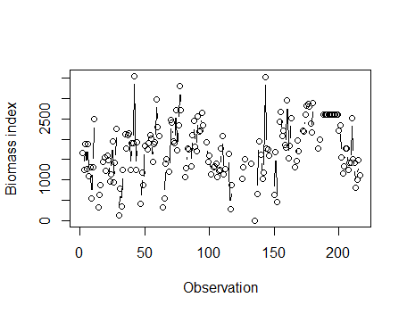The biomass index used in the final assessment model was extracted from the best-fit GLM (

Figure 11). See (Figure 7) for plot of catch and effort time series used in model.

Figure 11 **–** Extracted biomass index used in the stock assessment

## Stock assessment using the surplus production model SPiCT

Post-processing code supplied by Pedersen and Berg (2017) was used to investigate the results of the model fit to input data presented in (subsection 3.2.2). The relative biomass and fishing mortality time series for a generalised production model are shown in Figure 12. The seabob stock biomass appears to have declined from above 8,000 MT in 2003 to roughly 2,000 MT in 2018; with most estimates after the 2003-2005 period falling significantly below the Biomass which yields Maximum Sustainable Yield at equilibrium (BMSY), as indicated by the horizontal black line. Additionally, Absolute Fishing Mortality (Ft)is predicted to have increased from approximately 0.2/year to 1.6/year between 2001 and 2018 and exceedsFMSY from 2003 onwards. The predicted stock biomass for 2018 (Table 2) was >4 times smaller than the biomass required to achieve MSY (Table 3), with a predicted value for 2018 of 0.23. The upper (35,553 MT) and lower (8,704 MT) confidence intervals (CIs) for the deterministic absolute biomass (Mmsyd) were also very wide.

*Table 2.* *Deterministic reference points:*

|  |  |  |  |  |
| --- | --- | --- | --- | --- |
|  | **Estimate** | **Lower (CI)** | **Upper (CI)** | **Log estimate** |
| Bmsyd | 8704.1255365 | 2130.9574201 | 35552.940027 | 9.0715524 |
| Fmsyd | 0.5130994 | 0.1295856 | 2.031638 | -0.6672857 |
| MSYd | 4466.0815530 | 3622.5717424 | 5506.001221 | 8.4042667 |

*Table 3. Predictions (95% CI):*

|  |  |  |  |  |
| --- | --- | --- | --- | --- |
|  | **Prediction** | **Lower (CI)** | **Upper (CI)** | **Log estimate** |
| B_2018.12 | 2034.957295 | 446.3484735 | 9277.6192521 | 7.6182301 |
| F_2018.12 | 1.628361 | 0.4812673 | 5.5095350 | 0.4875739 |
| B_2018.12/Bmsy | 0.234536 | 0.0726968 | 0.7566649 | -1.4501461 |
| F_2018.12/Fmsy | 3.178114 | 1.1359910 | 8.8912726 | 1.1562878 |
| Catch_2018.12 | 504.143356 | 261.3430075 | 972.5170236 | 6.2228607 |
| E(B_inf) | NR | NR | NR | NR |

NR – no result

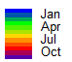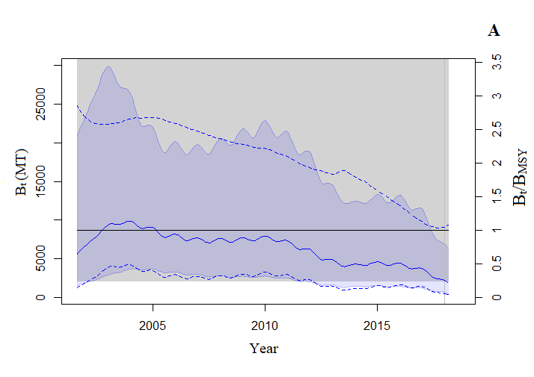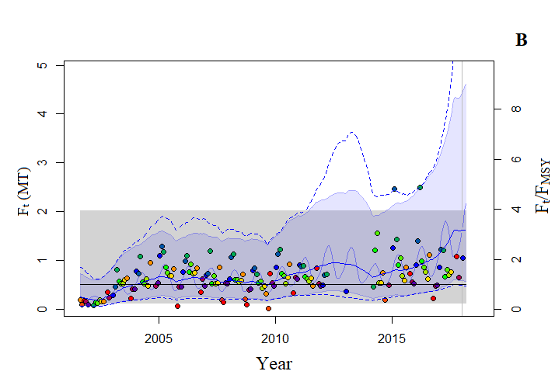

*Figure 12*. SPiCT estimates of (A) absolute biomass and (B) absolute fishing mortality time histories (2001 – 2018) assuming the generalised production model. The solid lines (blue) indicate the respective average biomass and fishing mortality, the shaded areas indicate 95% confidence intervals (CI). The Absolute Stock Biomass (Bt)is on the left side y-axis (A) and relative stock biomass (Bt/BMSY) is on the right side of the y-axis (A), with the 95% CI being between the dotted lines for Bt and between the shaded region for Bt/BMSY. Absolute fishing mortality (Ft)is on the left side y-axis (B) and relative fishing mortality (Ft/FMSY) is on the right side of the y-axis (B). The differently coloured points are fishing effort by months. The solid lines (blue) indicate the respective average biomass and fishing mortality, the shaded areas indicate 95% confidence intervals (CI). The horizontal solid lines denote the fishery reference point, that is, relative stock biomass at MSY (Bt/BMSY) in (A) and relative fishing mortality at MSY (Ft/FMSY) in (B). The fitted time series with a 2-year forecast and the beginning of the prediction time series is outlined by the upright grey line.

## Changes in size distribution over time

In all years examined, the weight of seabob predominantly ranged between 1 and 6 g (Figure 13). For the years 2008 to 2009 the observed size differences were less pronounced when compared to the years 2013, 2017 and 2018. The proportion of smaller seabob increased with time i.e. 70% is 4 g or less in 2008/2009 compared with 90% in 2018. The bootstrapped p-value from the K-S test (Table 4) suggests a significant difference in weight distributions betweenseabob captured in 2009 when compared to those captured in 2018 i.e. p < 0:00005).

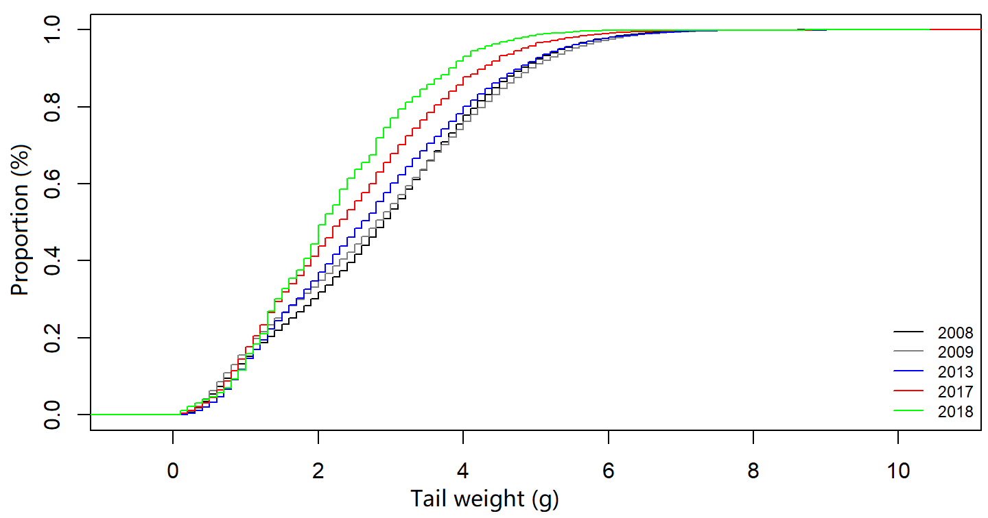

Figure 13. Empirical cumulative distribution function for seabob sampled between 2007 - 2018.

Table 4. Results obtained from the Kolmogorov-Smirnov (K-S) Test (seen in Figure 13)

|  |  |
| --- | --- |
| Parameters measured | Values |
| Bootstrap p-value | <2.22e-16 |
| Naïve p-value | 0 |
| Full sample statistic | 0.48374 |

There has been a notable decline in the numbers of large seabobcaught (Figure 14). The mean tail weights have decreased from 2.9 g in 2008 to 2.2 g in 2018. The median tail weights have also decreased from 2.9 g in 2008 to 2.1 g in 2018. The observed mean and median tail weights in 2018 were also lower than the combined mean (2.7 g) and median (2.6 g) between 2008 to 2018. From 2008 to 2018, more small shrimps were being caught and fewer large shrimp (Figure 15).

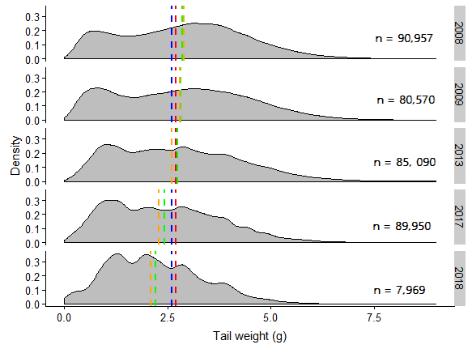

Figure 14. Smoothed distribution of seabob tail weights (g) sampled from January through? December (2008-2018). The lines on the plot represent the mean (red = 2.7g) and median (blue = 2.6 g) values. The orange dashed represents the median weight observed in sample each year, while the mean is shown in green and n = tail weight sample count.

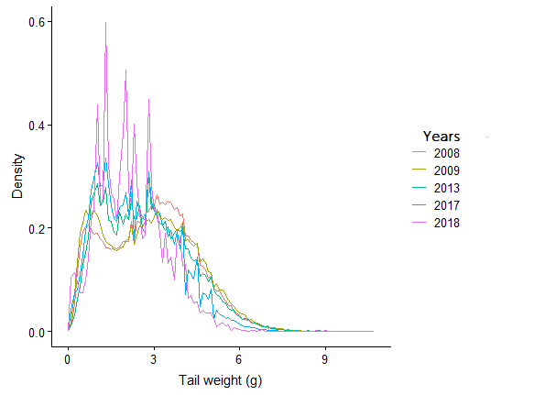

*Figure 15.* Relative seabob tail weight (g) distribution of individuals sampled from January through December (2008 - 2018)

## Spatial analysis of fishing effort

Most trawling occurred between latitudes 57°W to 58°W and longitude 6°N to 7°N (Figure 16). A total of 1,424,882 vessel positions were mapped; 460,919 (2015), 551,127 (2016) and412,836 (2017). In all years, the points (grey) recorded outside of the 7 to 18-fathom lines may suggest illegal fishing or the vessels are simply moving at fishing speeds but not fishing. The accuracy of this, however, can be tested through comparison of recorded fishing speeds from at-sea-observer data with VMS data. There is a clear fishing pattern amongst the years plotted with some level of inter-annual variations. Fishing intensity per location has become less dense i.e. maximum of ~1600 (2015) pings has reduced to ~1000 (2017); which spreads across a wider area.

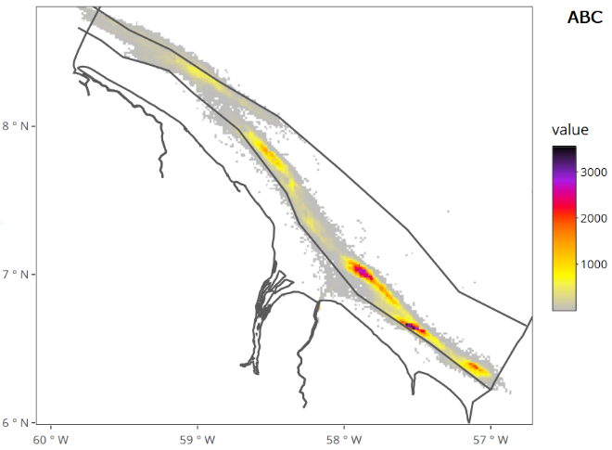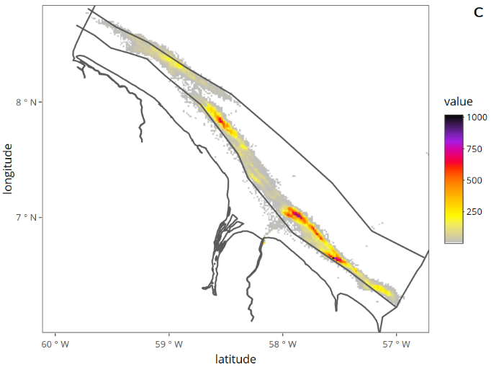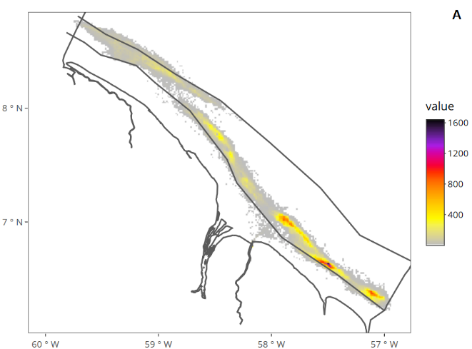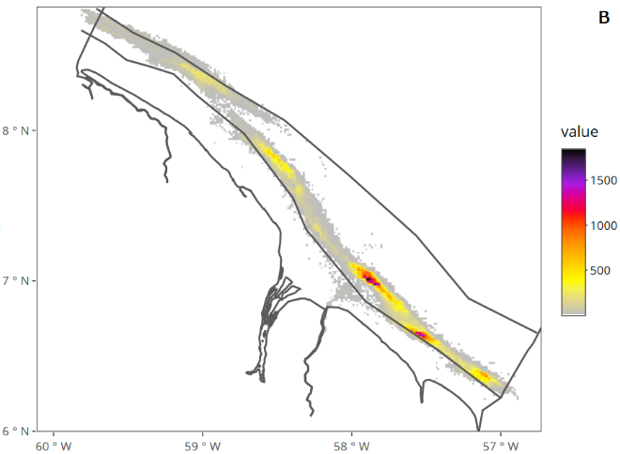

Figure 16. Density map of fishing effort within Guyana’s EEZ for 2015 (A), 2016 (B), 2017 (C) and 2015-2017 (ABC). The inner cone-shaped boundary lines illustrate the seabob fishing zone (i.e. 7 and 18-fathom lines) beyond which seabob vessels are not permitted to trawl by law. The applied colour scale i.e. dark to light represents the different trawling intensities. The black/purple highlighted represents the areas “most fished” or the cumulation of satellite pings over time.

## Analysis of last haul bycatch

### Haul composition

The minimum and maximum proportion of bycatch landed were 2% (trip 28) and 45% (trip 2) with the corresponding minimum (55%) and maximum (98%) seabob landings recorded in trips 2 and 28, respectively (Figure 17). The percentage of bycatch by last hauls was in excess of 10% except for trips 3, 17, 26, 27, 28 and 31, respectively.

Figure 17. Proportion (%) of seabob to total bycatch by weights for all last trips.

A total of 7183 kg (81%) of seabob and 1,721 kg (19%) of bycatch were recorded from the 25 trips sampled (Table 5). Species richness per sample ranged between 4 and 26 species, with a mean of 17 and a standard deviation of 5. The mean and median seabob weight landed per trip was 287 and 290 kg, respectively. The standard deviation from the mean was 118 kg, with a minimum trip weight of 90 kg (trip 2) and a maximum of 645 kg (trip 29). The mean and median bycatch landed per trip was 69 and 67 kg, respectively. The standard deviation from the mean was 43 kg, with a minimum trip weight of 8 kg (trip 28) and a maximum of 181 kg (trip 9).

Table 5. Trips weights for seabob and bycatch, bycatch % and bycatch species count.

|  |  |  |  |  |
| --- | --- | --- | --- | --- |
| **Trip no.** | **Seabob weight (kg/haul)** | **Bycatch weight (kg/haul)** | **Bycatch (%)** | **Bycatch Species count** |
| **2** | 89.93 | 79.07 | 46.79 | 17 |
| **3** | 380.95 | 19.68 | 4.91 | 14 |
| **5** | 302.78 | 142.14 | 31.95 | 26 |
| **6** | 230.20 | 60.10 | 20.7 | 15 |
| **7** | 157.51 | 73.91 | 31.94 | 12 |
| **8** | 173.65 | 90.70 | 34.31 | 18 |
| **9** | 253.57 | 180.66 | 41.6 | 19 |
| **10** | 299.11 | 88.88 | 22.91 | 24 |
| **11** | 397.13 | 63.15 | 13.72 | 12 |
| **12** | 192.69 | 51.75 | 21.17 | 18 |
| **13** | 199.61 | 55.69 | 21.81 | 20 |
| **17** | 304.37 | 19.95 | 6.15 | 4 |
| **18** | 290.48 | 54.42 | 15.78 | 11 |
| **19** | 515.68 | 76.64 | 12.94 | 11 |
| **20** | 300.79 | 67.59 | 18.35 | 20 |
| **21** | 172.56 | 44.37 | 20.45 | 14 |
| **22** | 189.56 | 76.47 | 28.74 | 22 |
| **23** | 274.24 | 130.49 | 32.24 | 27 |
| **24** | 206.21 | 83.28 | 28.77 | 21 |
| **25** | 268.00 | 66.60 | 19.91 | 10 |
| **26** | 302.58 | 21.04 | 6.5 | 20 |
| **27** | 315.08 | 16.34 | 4.93 | 20 |
| **28** | 343.93 | 8.46 | 2.4 | 15 |
| **29** | 645.24 | 127.49 | 16.5 | 17 |
| **31** | 377.14 | 22.44 | 5.62 | 18 |

### Bycatch composition

A total of 56 fish taxa were identified, which are hereafter referred to as “species” (Table 6). The fish species belonged to 32 families in 13 orders, with the Perciformes (23 species) being the dominant order. Species frequency in sample ranged between 1 and 24 species, with a mean of 8 and a standard deviation of 7. A total of 1,721 kg (19%) of bycatch were recorded from the 56 species sampled. *M. ancylodon* (17%), *Stellifer microps* (13%), *C. virescens* (11%), *N. microps* (8%) and *Trichiurus lepturus* (6%) were the five most common species in terms of total biomass (Figure 18). All together these five species recorded more than 55% (945 kg) half of the total biomass. The mean and median weights landed per species was 31 and 6 kg, respectively. The standard deviation from the mean was 57 kg, with the minimum total species weight recorded being 0.01 kg (*Selene vomer*) and a maximum of 289 kg (*M. ancylodon*). The mean CPUE (kg/n) per species was 3 kg. The standard deviation from the mean was 5 kg, with a minimum of 0.01 kg/n and a maximum of 31.4 kg/n. The proportion of individual species weight in the sample ranged from 0.0008% (*Selene vomer*) to 17 % (*M. ancylodon*).

A total of 715 individual fish were measured for the three most common commercial species sampled to the closest cm. The count of seatrout(319) measured in the sample was almost double that of butterfish(126), followed by bangamary (270). Length measurements for the three species ranged up to 40 cm (Figure 19). The mean: median sample lengths for the respective the three species were: seatrout(17: 17 cm), butterfish(18: 18 cm) and bangamary (16: 15 cm). The standard deviation from the mean were: seatrout(4.75 kg), butterfish(6.28 kg) and bangamary (5.37 kg). The observed length ranges for the three species were: seatrout4 - 28 cm, butterfish5 - 36 cm, and bangamary 4 - 29 cm. This result meant that for all species the relative sizes caught were below maturity and common lengths (Appendix 6).

Table 6. Categorisation of bycatch species in the 25 last haul samples. Where n = the number of trips where species were present.

|  |  |  |  |  |  |
| --- | --- | --- | --- | --- | --- |
| Order | Family | Species | Weight (kg) | % | n |
| Anguilliformes | Muraenesocidae | *Cynoponticus savanna* | 3.56 | 0.21 | 3 |
|  | Muraenidae | *Gymnothorax ocellatus* | 0.57 | 0.03 | 1 |
|  | Ophichthidae | *Ophichthus gomesi* | 45.07 | 2.62 | 13 |
| Batrachoidiformes | Batrachoididae | *Batrachoides surinamensis* | 17.89 | 1.04 | 18 |
| Carcharhiniformes | Chondrichthyes | *Sphyrindae spp.* | 3.17 | 0.18 | 1 |
| Clupeiformes | Clupeidae | *Harengula jaguana* | 0.34 | 0.02 | 4 |
|  | Engraulidae | *Anchoa mitchilli* | 18.09 | 1.05 | 12 |
|  |  | *Anchoa spinifer* | 7.51 | 0.44 | 6 |
|  |  | *Anchoviella lepidentosole* | 1.27 | 0.07 | 2 |
|  | Pristigasteridae | *Pellona harroweri* | 23.12 | 1.34 | 7 |
| Decapoda | Calappidae | *Calappa sulcata* | 0.27 | 0.02 | 1 |
|  | Leucosiidae | *Persephona lichtensteinii* | 0.46 | 0.03 | 2 |
|  | Malacostraca | *Hepatus gronovii* | 1.66 | 0.10 | 4 |
|  | Palaemonidae | *Nematopalaemon schmitti* | 47.71 | 2.77 | 6 |
|  | Portunidae | *Callinectes ornatus* | 9.67 | 0.56 | 5 |
| Myliobatiformes | Gymnuridae | *Gymnura micrura* | 44.00 | 2.56 | 17 |
|  | Myliobatidae | *Rhinoptera bonasus* | 31.40 | 1.82 | 1 |
|  | Urotrygonidae | *Urotrygon microphthalmum* | 0.23 | 0.01 | 1 |
| Perciformes | Carangidae | *Caranx hippos* | 4.24 | 0.25 | 2 |
|  |  | *Chaetodipterus faber* | 5.91 | 0.34 | 9 |
|  |  | *Chloroscombrus chrysurus* | 0.10 | 0.01 | 2 |
|  |  | *Selene browni* | 5.93 | 0.34 | 10 |
|  |  | *Selene Vomer* | 0.01 | 0.00 | 1 |
|  | Centropomidae | *Centropomus pectinatus* | 5.30 | 0.31 | 3 |
|  |  | *Centropomus undecimalis* | 1.33 | 0.08 | 1 |
|  | Haemulidae | *Conodon nobilis* | 0.20 | 0.01 | 2 |
|  |  | *Genyatremus leteus* | 1.45 | 0.08 | 2 |
|  | Lobotidae | *Lobotes surinamensis* | 5.70 | 0.33 | 2 |
|  | Polynemidae | *Polydactylus virginicus* | 2.58 | 0.15 | 3 |
|  | Sciaenidae | *Cynoscion virescens* | 186.73 | 10.85 | 24 |
|  |  | *Larimus breviceps* | 33.27 | 1.93 | 7 |
|  |  | *Macrodon ancylodon* | 289.09 | 16.79 | 24 |
|  |  | *Menticirrhus americanus* | 7.54 | 0.44 | 2 |
|  |  | *Micropogonias furnieri* | 44.01 | 2.56 | 6 |
|  |  | *Nebris microps* | 140.74 | 8.18 | 20 |
|  |  | *Paralonchurus elegans* | 44.37 | 2.58 | 14 |
|  |  | *Paralonchurus braziliensis* | 56.29 | 3.27 | 16 |
|  |  | *Rypticus maculatus* | 0.62 | 0.04 | 1 |
|  |  | *Stellifer microps* | 225.46 | 13.10 | 20 |
|  |  | *Stellifer rastrifer* | 64.88 | 3.77 | 11 |
|  | Trichiuridae | *Trichiurus lepturus* | 103.26 | 6.00 | 21 |
| Pleuronectiformes | Achiridae | *Apionichthys dumerili* | 2.74 | 0.16 | 5 |
|  | Actinopterygii | *Achirus achirus* | 12.84 | 0.75 | 15 |
|  | Cynoglossidae | *Symphurus plagusia* | 54.91 | 3.19 | 22 |
| Rajiformes | Dasyatidae | *Dastyis guttata* | 72.53 | 4.21 | 16 |
|  |  | *Dasyatis geijskesi* | 5.14 | 0.30 | 4 |
| Siluriformes | Ariidae | *Amphiarius rugispinis* | 1.17 | 0.07 | 1 |
|  |  | *Aridae spp.* | 6.68 | 0.39 | 2 |
|  |  | *Arius proops* | 18.67 | 1.08 | 10 |
|  |  | *Bagre bagre* | 21.12 | 1.23 | 17 |
| Stomatopoda | Squillidae | *Squilla mantis* | 3.15 | 0.18 | 8 |
| Tetraodontiformes | Diodontidae | *Diodon holacanthus* | 0.02 | 0.00 | 1 |
|  | Tetraodontidae | *Colomesus psittacus* | 33.53 | 1.95 | 13 |
|  |  | *Sphoeroides parvus* | 0.29 | 0.02 | 1 |
|  |  | *Sphorades testudineus* | 0.05 | 0.00 | 1 |
| Torpediniformes | Narcinidae | *Narcine brasiliensis* | 3.48 | 0.20 | 4 |

Figure 18. Proportional representation of the most common bycatch species in last haul data by biomass. Bangamary (17%), seatrout (11%) and butterfish (8%) were species of commercial importance to Guyana and are target species for the artisanal fishery. These were 5% of the total species sampled, however they were responsible for 36% percent of the total sampled biomass.

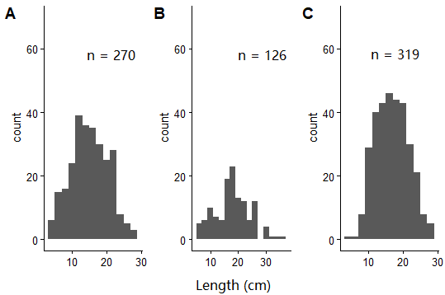

Figure 19. Length frequency distribution of the three most common commercially important bycatch species caught in last haul. Where n = number of individuals measured.

### Species selection and mapping

The three most common commercially important species: bangamary, butterfish and, seatrout were selected to compare with seabob based on their high relative richness in the sampled last haul bycatch and because of their importance to Guyana and other countries as harvested species. Twenty-two of 31 last haul trips were missing VMS data and needed to be excluded. A total of 33 data points containing catch weights (kg) across 9 fishing trips (2015 – 2017) were plotted: 9 for seabob, 8 for bangamary*,* 7 for butterfishand 9 for seatrout. This result indicates that only seabob and seatrout were present in all plotted trips. The annual biomass range for seabob across all trips (9 observations) was 190 – 516 kg, while the other three species had a range of 0.1 – 48.3 kg (24 observations) (Table 7).

Table 7. Trip identification number, haul date, species, biomass data, fishing speed and number of observations (n) used to create bycatch maps.

|  |  |  |  |  |
| --- | --- | --- | --- | --- |
| Trip no. | Species | Weight (kg) | Haul date | Haul speed |
| 3 | *Cynoscion virescens* | 0.2 | 19/11/2015 | 1.5 |
|  | *Nebris microps* | 3.9 | 19/11/2015 | 1.5 |
|  | *Macrodon ancylodon* | 3.1 | 19/11/2015 | 1.5 |
|  | *Xiphopenaeus kroyeri* | 381.0 | 19/11/2015 | 1.5 |
| 5 | *Cynoscion virescens* | 25.4 | 13/1/2016 | 2.5 |
|  | *Macrodon ancylodon* | 17.5 | 13/1/2016 | 2.5 |
|  | *Nebris microps* | 6.3 | 13/1/2016 | 2.5 |
|  | *Xiphopenaeus kroyeri* | 302.8 | 13/1/2016 | 2.5 |
| 9 | *Cynoscion virescens* | 3.6 | 18/4/2016 | 2.5 |
|  | *Macrodon ancylodon* | 48.3 | 18/4/2016 | 2.5 |
|  | *Nebris microps* | 3.6 | 18/4/2016 | 2.5 |
|  | *Xiphopenaeus kroyeri* | 253.6 | 18/4/2016 | 2.5 |
| 10 | *Cynoscion virescens* | 1.8 | 3/5/2016 | 3 |
|  | *Macrodon ancylodon* | 9.1 | 3/5/2016 | 3 |
|  | *Nebris microps* | 0.5 | 3/5/2016 | 3 |
|  | *Xiphopenaeus kroyeri* | 299.1 | 3/5/2016 | 3 |
| 11 | *Macrodon ancylodon* | 16.3 | 28/6/2016 | 3 |
|  | *Cynoscion virescens* | 0.1 | 28/6/2016 | 3 |
|  | *Xiphopenaeus kroyeri* | 397.1 | 28/6/2016 | 3 |
| 17 | *Cynoscion virescens* | 0.9 | 11/11/2016 | 3 |
|  | *Xiphopenaeus kroyeri* | 304.4 | 11/11/2016 | 3 |
| 19 | *Macrodon ancylodon* | 10.9 | 25/1/2017 | 3 |
|  | *Nebris microps* | 5.4 | 25/1/2017 | 3 |
|  | *Cynoscion virescens* | 5.4 | 25/1/2017 | 3 |
|  | *Xiphopenaeus kroyeri* | 515.7 | 25/1/2017 | 3 |
| 20 | *Macrodon ancylodon* | 7.1 | 7/2/2017 | 2.5 |
|  | *Nebris microps* | 7.1 | 7/2/2017 | 2.5 |
|  | *Cynoscion virescens* | 4.7 | 7/2/2017 | 2.5 |
|  | *Xiphopenaeus kroyeri* | 300.8 | 7/2/2017 | 2.5 |
| 22 | *Nebris microps* | 18.4 | 28/12/2017 | 2.88 |
|  | *Cynoscion virescens* | 19.1 | 28/12/2017 | 2.88 |
|  | *Macrodon ancylodon* | 4.8 | 28/12/2017 | 2.88 |
|  | *Xiphopenaeus kroyeri* | 189.6 | 28/12/2017 | 2.88 |

A total biomass of 2,944 kg seabob and 117 kg bangamary were plotted (Figure 20). The mean biomass over the respective years was 381 kg (2015), 311 kg (2016) and 335 kg (2017) for seabob and 3.1 kg (2015), 23 kg (2016) and 7 kg (2017) for bangamary. The standard deviation from the mean by year was 52 kg (2016) and 166 kg (2017) for seabob and 17 kg (2016) and 3.08 kg (2017) for bangamary. There was no standard deviation calculated for both species in 2015, as there was a single trip plotted.

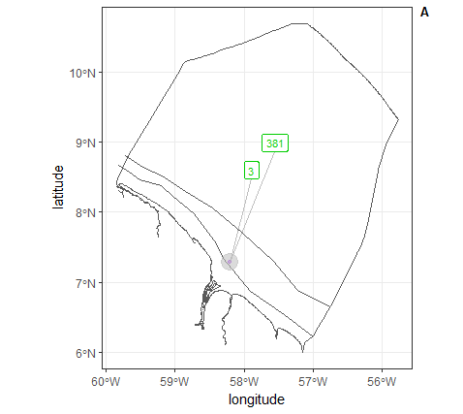

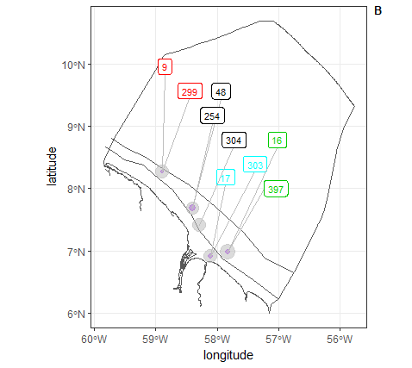 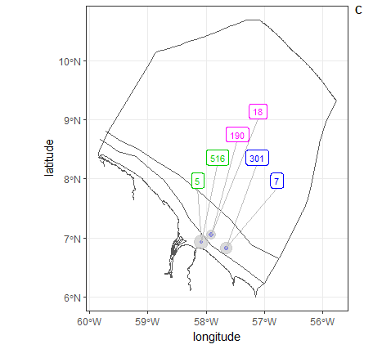

Figure 20. Distribution of the seabob and bangamary caught in the last haul between 2015 and 2017. The conically shaped lines which enclose the catch are the inner and out boundary lines, i.e. 7 and 18-fathom lines, respectively. Where plot labels A = 2015, B = 2016 and C = 2017. The paired boxes with similar colour represent a single trip with the numbers being the catch weights (kg) of seabob and bangamary. The larger of the two numbers was always seabob. Where there is a single box, no bangamary was recorded in the catch. In order of left to right from on plots (numbers = trip identification number); Plot A; green = 3, Plot B; red = 10 , black (double) = 9, black (single) = 17, blue = 5, green = 11 and Plot C; green = 19, pink = 22, blue = 20.

The biomass for seabob in Figure 21 and Figure 22 are similar to that in Figure 20. Total biomass of 45 kg butterfish was plotted (Figure 21). The mean biomass over the respective years was 4 kg (2015), 3 kg (2016) and 10 kg (2017) for butterfish. The standard deviation from the mean was 2.90 kg (2016) and 7.07 kg (2017) for butterfish.

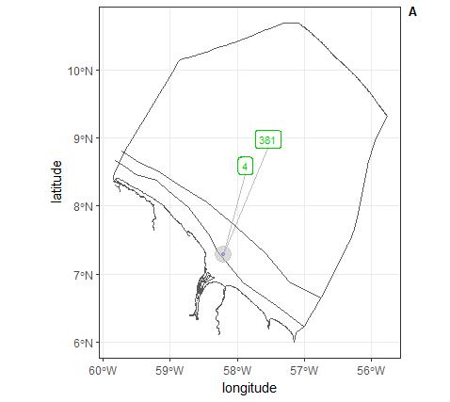

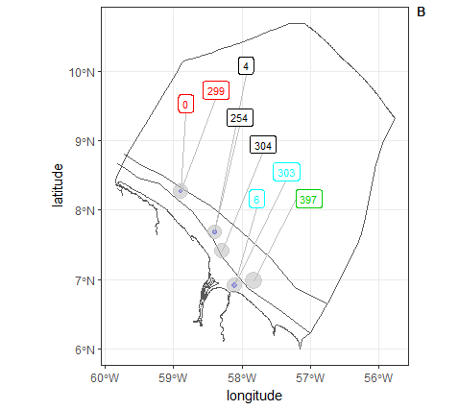 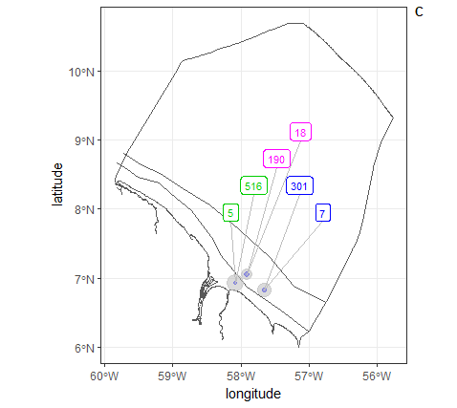

Figure 21. Distribution of the seabob and butterfish caught in the last haul between 2015 and2017. The conically shaped lines which enclose the catch are the inner and out boundary lines, i.e. 7 and 18-fathom lines, respectively. Where plot labels A = 2015, B = 2016 and C = 2017. The paired boxes with similar colour represent a single trip with the numbers being the catch weights (kg) of seabob and butterfish. The larger of the two numbers was always seabob. Where there is a single box, no butterfish was recorded in the catch; 0 represents butterfish < 0.5 kg. In order of left to right from on plots (numbers = trip identification number); Plot A; green = 3, Plot B; red = 10 , black (double) = 9, black (single) = 17, blue = 5, green = 11 and Plot C; green = 19, pink = 22, blue = 20.

These results suggest that there is strong evidence of species overlaps across sampled trips. This may have been influenced by the non-selectivity of the trawl gear cited by many authors.

Total biomass of 61 kg seatrout was plotted (Figure 22). The mean biomass over the respective years was 0.2 kg (2015), 6 kg (2016) and 10 kg (2017) for seatrout. The standard deviation from the mean by year was 11 kg (2016), 8.12 kg (2017) for seatrout.

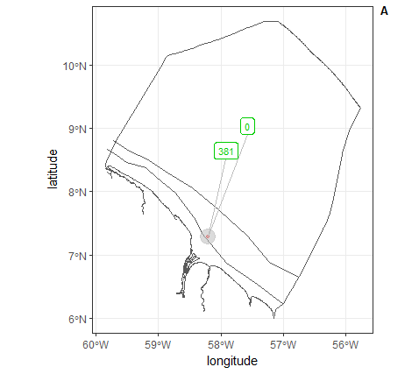

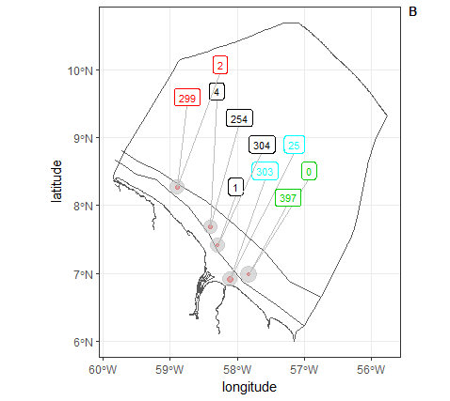 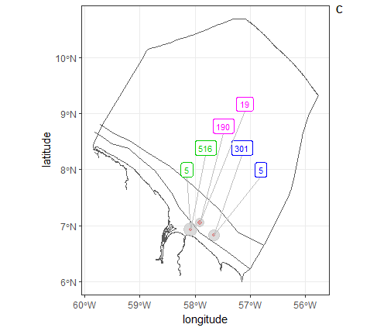

Figure 22. Distribution of the seabob and seatrout caught in the last haul between 2015-2017. The conically shaped lines which enclose the catch are the inner and out boundary lines, i.e. 7 and 18-fathom lines, respectively. Where plot labels A = 2015, B = 2016 and C = 2017. The paired boxes with similar colour represent a single trip with the numbers being the catch weights (kg) of seabob and seatrout. The larger of the two numbers was always seabob. Where there is a single box, no seatrout was recorded; 0 represents seatrout < 0.5 kg. In order of left to right from on plots (numbers = trip identification number); Plot A; green = 3, Plot B; red = 10 , black (double) = 9, black (single) = 17, blue = 5, green = 11 and Plot C; green = 19, pink = 22, blue = 20.

# DISCUSSION

Guyana`s seabob bottom trawl fishery has over the years been known from landing high seabob catches relative to other countries along the coast of the Americas (Figure 1). At the same time the fishery, like other shrimp trawl fishery globally, is known for having high levels of bycatch. It, therefore, is important that regular assessments be conducted on the seabob species and the composition and distribution of bycatch generated by the fishery by utilising the best available catch and effort, biological and spatial data, which will inform evidence-based management. It is important also for any gap identified during such analyses to be addressed in order to improve on past the results. Against this background, this paper aims to address these areas with the hope of improving management of the seabob fishery through the results generated herein.

## Stock status and future considerations

Annual data from 2001 to 2018 were used in the model, the model did not converge which was an indication that the data did not fit the model well, which may have resulted from too many poorly fitting observations. The approach to averting this was the use of subannual (by month observations) data instead in the model (Pedersen & Berg, 2017). The model at this point did not converge but started to fit more of the data, which was concluded by the evidence of less errors in the results. The model finally converged when the calculated biomass index was reconverted to effort data. Pedersen et al. (2018) documented that the use of effort data directly instead of commercial CPUE is cleaner and evades data duplication, so results based on using effort as input were retained for analysis. The difficulties in convergence may have also been as a result of fewer data points for the annual data as oppose to the subannual data which lead to worse convergence and because duplication of information in the initial model i.e. catch as catch and catch in catch/effort which induced a correlation, which the model does not account for (Pedersen, Berg, & Kokkalis, 2018). Pedersen et al. (2018) also stated that the replacement of CPUE biomass index with effort do not impact the overall results in terms of stock status. Given the range of assumptions and uncertainties discussed, one way of having more reliable CPUE estimates is from independent surveys, where there are broader sampling coverage and less bias sampling; as fishers will intuitively tend to go where fishing conditions are most favourable.

The stock assessment showed a decline in stock biomass from roughly 8,000 MT in 2003 to roughly 2,000 MT in 2018; with most estimates post 2003-2005 period falling significantly below the expected BMSY (Figure 12). The results also showed that overall fishing mortality (Ft) increased from approximately 0.2/year to 1.5/year between 2001-2018 and exceedsFMSY from 2003 onwards, despite reported catch data remaining relatively unchanging across the same span of years. Based on the stock assessment results the stock is currently in an overfished state, as both the Ft (1.5/year) is approximately three times above the desired level at FMSY (0.51/year) and the predicted Bt (2034 MT) for 2018 is four times smaller than the biomass required at MSY (8,704 MT). However, the 95 % CIs calculated for the deterministic biomass estimate was extremely wide i.e. 2,131 MT (lower CI) and 35,553 (Upper CI). This result means that with 95% confidence, the mean biomass can be at any value within the given range, which significantly reduces the precision of the estimated deterministic biomass and consequently the confidence in using the result for management purposes. Moreover, analysis on the shrimp sizes by year, has revealed that average tail weights have been consistently declining. The results revealed that the percentage of smaller seabob increased with time i.e. 70% is 4 g or fewer tail weights were observed in 2008 compared with 90% in 2018 (Figure 13). A K-S test (Table 4) revealed that this difference was significant i.e. p < 0.00005).

The results from the stock assessment are very different from that generated by the previous stock assessment, where the stock was said to be close to a default precautionary target level and therefore was deemed fully exploited, but not overfished (Medley, 2013). The said assessment revealed that fishing mortality infrequently surpassed fishing mortality at MSY, which meant that overfishing seldomly occurred (Figure 4). These differences may be attributed to i.a. challenges encountered when fitting the model, accuracy of data used and or model simplicity. The model may be improved by adjusting the default model parameters, which can lead to a reduction in the CIs for the predicted stock biomass; noted earlier to be undesirably wide. Therefore, these results should not be used for scientific advice at this stage of development, pending further evaluation and possible adjustments. Furthermore, there is also a strong case that the reduction in shrimp sizes, could have contributed to the decline in estimated biomass, though this information was not explicitly used in the model. The decrease in sizes of shrimp with time can be a result of several factors, which will require further research and analysis to prove scientifically. These factors can include i.a. food web imbalance, decrease in per-capita food and nutrient availability due to large population increases and increased metabolic demands from changes in the environment e.g. increased temperature. Alternatively, fishing might have had an accelerating effect on environmentally driven decreases in shrimp growth and size by ‘cropping’ the largest shrimp from the population. The wide range of probable causes indicates that further research is needed to diagnose the source (s) for the decrease in average shrimp sizes.

The selection of the SPiCT model was influenced by factors such as applicability to data-limited situations and its ability to model in continuous-time to catch data, biomass indices and fishing effort (Pedersen, Berg, & Kokkalis, 2018). Generally, the results generated by stock production models should be examined with great care and caution due to the many assumptions made and they should not be a replacement for more complex and robust models (Sparre & Venema, 1998). Generally, surplus production models have been extensively used in managing fisheries, but they suffer from an absence of biological practicality (Ludwig & Walters, 1985). These models are often seen as "poor cousins" of age-structured ones (Hilborn and Walters, 1992). Hilborn et al. however, noted that various problems, for example, poor contrasts between effort and stock abundance, are common with both surplus production and age-structured models; furthermore, they remarked that surplus production models may "provide better estimates of management parameters than age-structured approaches even when important parameters such as growth and vulnerability are known" (Hilborn & Walters, 1992).

In addition, the accuracy of the assessment is also dependent on the input data, and whether all relevant factors that affect CPUE were appropriately included in the models. Historically catch-per-unit-effort has been suspicious of not always being proportional to abundance, as it is a result of several assumptions. These assumptions are i.a. fishing vulnerability to the fishing gear, stock spatial distribution and independence of each fishing activity (Petrere, Giacomini, & De Marco, 2010). Harley et al. (2001) analysed the proportionality between CPUE and abundance and found actual conditions where CPUE was most likely to be high when there is a decline in stock abundance. The CPUE standardisation procedure presented here may be due to the limited explanatory variables considered (year, month, days-at-sea, fuel, vessels), as numerous other factors may also disturb CPUE, like weather, fishing locations, and gear standardisation. Generally, the measure of days-at-sea is limited in that it does not convey information about the actual time spent fishing because it is not differentiated into net soak time relative to the time spent/area covered travelling to fishing ground.

## Bycatch and its implications for management

The analysis of the last haul data revealed that there was a total of 56 unique fish taxa (species). This finding was somewhat like another study on seabob catch data done in 2018 where a count of 16 more species (72) was observed (Willems, 2018). These species are categorised into two broader groups based on their economic significance. The first group contains those that are economically valuable/commercially important (often landed as bycatch) and the second group is those that have no/infinitesimal economic value or are commercially unimportant (usually discarded at sea). The ratio of economically valuable to economically unimportant species in the last haul data was roughly 50:50 by species presence in the sample. Length frequency analysis was done on species contained in the last haul data also revealed that many of the species were either immature or juveniles with few adults. This conclusion was drawn as their observed mean lengths were on average below their expected relative common lengths (Froese & Pauly, 2018). Importantly, the lengths recorded for the three most common commercial species (all of the Sciaenidae family) were all below the maturity and or common lengths associated with the respective species (see subsection 4.5.2 and Appendix 6 ), (Froese & Pauly, 2018). Nevertheless, it is important to note that that bycatch species ≥ 30 cm in length are also discarded, especially those that are of low economic value and for which no other usage exists (Kalicharan, 2016).

Information on the spatial and temporal distribution of bycatch species relative to fishing grounds could guide managers in knowing i.a. which area (s) to allow or disallow fishing in order to catch or avoid species, if strong spatial or temporal patterns in an overlap between the target and non-target species are observed from analyses. Adding spatial or temporal closures to seabob fishing grounds could improve its management by restricting fishing in areas for example where large biomasses and or vulnerable bycatch species are most abundant. This led to the design of the study to analyse and capture both catch and bycatch spatiotemporal fishing patterns by plotting biomass onto maps. Unfortunately, there were not enough data available to draw strong conclusions and create informative plots from the observed fishing patterns. This was as a result of errors encountered when combining VMS and bycatch data. These errors were primarily as a result of vessel names and fishing dates for similar trips being different. Nevertheless, the bycatch maps presented here (subsection 4.5.3), did provide preliminary information on relative species biomass and distribution for bangamary, butterfish and seatrout. The analysis will be improved in the future through the availability of more data and the exploration of better mapping tools, and hopefully improvements in data collection procedures and quality assurance (see next section).

The disclosure that the three most common[5] commercially important species (which were also in the top five most common species) were harvested below their respective maturity sizes is a cause for concern and should be investigated by fisheries managers. Bangamary, butterfish, and seatrout are of economic importance also to the artisanal fishery and measures should be adopted to improve their management, such as having management plans with the appropriate harvesting strategies to avoid overfishing (Medley, 2017; Gascoigne, 2013). High fishing mortality on unmatured fishes over an extended time may result in recruitment overfishing which can have severe economic and sustainability implications. Importantly, the seabob trawl vessels are equipped with BRDs and are lawfully required to use same while fishing to reduce finfish bycatch. Enforcement activities to ensure compliance with this legislation is strongly advised in keeping with MSC guidelines on the management of secondary species (P2). Additionally, there should be an examination of the usefulness of other bycatch reduction devices that exclude small fishes from the trawls (Willems, 2018). Further research into more advanced gear technology can also be pursued as an avenue for the reduction in juvenile finfish bycatch. There is also an urgent need for stock assessment on some of Guyana`s commercial finfish species, as presently only the seabob has an updated stock assessment (Medley, 2017). For example, stock assessments of the commercially important species caught as juvenile bycatch in the seabob fishery would indicate whether the resulting fishing mortality was high enough to cause recruitment overfishing.

## Data used, challenges and improvements

Three broad categories of data were utilised during this study, including seabob catch and effort data, last haul bycatch data and VMS data. These datasets were merged at different times to perform different analyses through the course of this study. This requirement led to the discovery of multiple inconsistencies and gaps within the data sources, as is the case for datasets in many developing countries. It is believed, however, that most of the data challenges encountered during the analyses, may have been a result of the relative newness of the data collection programs (VMS and last haul), as it generally takes time to work out bugs in data collection and storage methodology, which are only revealed after the data have been used. Such bugs included, for example, recording the same vessels with different names, incorrect species naming, absence of data for sampling trips, arrival and departure dates, unusually high/low quantitative observations and inappropriate formatting.

The findings resulted in extensive efforts being used for data manipulation and cleaning, which in some cases, forced intuitive assumptions where most (not all) conditions were satisfied before acceptance, and in other cases, it resulted in the omission of questionable data. This situation ultimately resulted in the loss of what may have been critical data, which may have otherwise impacted the results differently. An example where a huge amount of data was lost was in creating the bycatch maps, for which the last haul and VMS data needed to be combined. The challenge of matching fields in this instance resulted in large proportions of the last haul trips (31 trips (78%)) being discarded from the analysis. This fact is unfortunate as it greatly reduced the sample size and limited the data available for exploration of fishing patterns and catch distributions.

Noteworthy is the fact that the primary issues encountered during the analysis were largely due to data inconsistencies and not necessarily the absence of data. There is therefore currently a functioning system in place to collect data which has made this analysis possible, and therefore a good foundation from which improvements can be made. Against this background, it is pertinent that data collection continues while making the requisite adjustments to improve the data quality with time. Some steps toward improvement may include for example the training of local staff in data management and importance (i.e. collection, entry, storage and quality), having a standard format for data entry which is regularly updated, using the same name for vessels across data types, instituting appropriate quality control measures and using a database for data entry and storage. These improvements are necessary, considering that data collection can be very costly; therefore, there should be standards in place to monitor data quality in order to optimise its use and prevent wasting administrative resources.

# CONCLUSION

The management of the seabob trawl fishery has been improving, largely through a greater appreciation for the need for sustainable fisheries. This improvement can be attributed to many actions, for example, collaborative works done by the Fisheries Department and the seabob industry (Guyana Association Trawler Owners and Seafood Processors). Through their persistent efforts and dedication, these entities, in the recent past, have succeeded in instituting measures to improve the overall management of the seabob trawl fishery. These methods include drafting of fisheries regulations (which includes VMS and bycatch bylaws) and a Management Plan for the seabob fishery (both of which were recently approved by the Minister of Agriculture); implementation of the last haul programme (with greater sampling intensity) and the recent application for MSC certification; which if achieved would see Guyana becoming the first English speaking country in South America to have done so (P. Medley, pers. comm.). Nevertheless, there is a need for improvements in e.g., data management i.e. availability, structure, storage and quality and bycatch species management aimed at further reducing bycatch.

The SPiCT model output suggests that the stock is currently in an overfished state. This result is unlike that generated by the previous stock assessment (Medley, 2013). Additionally, the analyses of temporal seabob tail weights uncovered a consistent decline in annual mean sizes. Nevertheless, contrary to these findings it was observed that the overall CPUE has increased (see subsection 2.5.1) in recent years subsequent to the implementation of the HCR. Against this background, it is not advisable to use these results for scientific advice at this stage of development, as they are inconsistent and inconclusive, however, it does serve as a reminder that the previous stock assessment indicated that at best, the seabob stock was fully exploited five years ago, and that small changes to productivity of the stock or fishing rates could quickly change the stock to an overexploited state. Therefore, a precautionary approach is encouraged, to avert possible threats of overfishing and or potential stock collapse i.e. if the results obtained is somewhat realistic.

Understanding the spatiotemporal nature of catch composition and distribution is an important first step towards identifying species overlap and fishing patterns and managing fisheries spatially. In order to achieve this, there needs to be data collection tailored towards gathering enough information on fishing grounds/areas and relative catches. The data gathered can then be analyzed, and the results used to guide marine spatial planning aimed at reducing unwanted catch and protecting vulnerable species and habitats. It is therefore imperative that both the last haul and VMS data collection system be maintained and improved to allow for a more complete analysis of the data.

# RECOMMENDATIONS

As stated in the Introduction, the overall goal of this study was to conduct an analysis on the seabob and bycatch from Guyana`s seabob fishery by looking at the relative distribution and status within the established fishing zone. Provided here is a summary of some recommended measures that could be used to improve similar studies in the future and improve the sustainable management of Guyana`s seabob fishery.

* A significant amount of time was invested in cleaning and final preparation of the data for analysis. Moving forward staff time should be allotted to data preparation and formatting after the data is entered, as they are both critical prerequisites to any analysis.
* The use of an adaptable database for data entry and storage will improve data quality by reducing errors and data access to staff to do analysis.
* There should be continued analysis on VMS and last haul data to identify potential data gaps and errors which will guide needed actions for improvements. Such analysis will also inform alternative forms of management for example zoning/closed areas over time and or space, thus helping to reduce the co-occurrence of catch and bycatch species within hauls.
* The accuracy of the criteria used (i.e. one to three knots) to identify trawling speed during this study, should be studied. While the speed criterion is widely applied to denote fishing, they are exceptions, for example, a vessel can be moving at these speeds just before or after actual fishing. To improve on this assumption, data of fishing times and locations from a last haul/at-sea-observer logbooks can be cross-referenced with VMS data.
* Further practical testing of other bycatch reduction devices which exclude small fishes and total bycatch from the trawls should be explored.
* Stock assessments should be conducted on finfish species locally; as presently only the seabob has an updated stock assessment. This may require additional data collection which will be best identified if the process starts early.
* The stock assessment should be reviewed and improved where necessary. Following this process, if the results obtained are partially true then the appropriate management measures should be instituted to improve management of the stock for example re-evaluation of the harvest control rule.

# ACKNOWLEDGEMENTS

I wish to extend sincere thanks first and foremost to the God of Abraham, Isaac, and Jacob for blessing me with this ground-breaking/seed germinating opportunity. Special thank you to my gorgeous wife (my gem) for releasing me for 6 months from her presence; your sacrifice and daily support will always be cherished and remembered. I am grateful to Chester`s and the Butt`s family for the comfort they provided to my wife during my absence.

A huge thank you to the United Nations - University Fisheries Training Program (UNU – FTP) administration for their accommodation, moral support, encouragements and guidance during the programme. Special thanks go to my supervisors/mentors Drs. Pamela J. Woods and Ingibjörg G. Jónsdóttir for your guidance, patience, hard work and dedication. I truly am inspired, moved by and admire your work ethic energy and your high level of professionalism. Unwavering thanks go to Tumi Tómasson, Þór H. Ásgeirsson, Mary Frances, Stefán Úlfarsson and Julie Ingham. My admiration for you guys is beyond what I can express herein. Rest assured you have left a lasting impression of what teamwork really means and the price and sacrifices required to build a united team of successful people. I have observed your becoming conduct, both individually and collectively and plan on adopting your model to my professional life and during my work experience. Thanks to every lecturer/facilitator for your teachings and sharing of your expertise and advise. It would be remiss of me if I failed to mention my admiration for two special characters; Julian Burgos (my brother) and Einar Hjorleifsson (aka “the cool guy”). Julian whom I enjoyed frequent interactions with and who assisted me greatly in developing R-codes and my coding skills generally and Einar whose practicality, brilliance and simplicity of character I greatly admired.

I wish to thank Mr. Denzil Roberts (Chief Fisheries Officer) for his nomination and Ms. Delma Nedd (Permanent Secretary) and Mr. Noel Holder (Minister of Agriculture) for affording me time away from my department/office to attend this important programme. Special thanks also extend to Ms. Dawn Maison (2007 UNU-FTP fellow) who motivated me to undertake this venture and always lent her support to me while in Iceland, your input was invaluable. The support of the Caribbean Regional Fisheries Mechanism (CRFM); Ms. June Masters (2007 UNU-FTP fellow) and Ms. Pamela Gibson (Student representative) have been remarkable; the bridge the organisation has built, and the support team is impeccable, and much appreciated.

Thanks to the Filadelfia Church for their prayers and spiritual upliftment, while in Iceland and to Sis. Doreen (my Guyanese-Icelandic mother) for treating me as she would her son; truly energetic and special woman, stay blessed. I will like to thank my colleagues I met on the UNU-FTP programme and those from the Fisheries Department (Guyana) for the information they assisted me with and their moral support. Thanks to the fishing industry, for collecting the data which made this study possible.

Thanks to anyone I may have forgotten to mention directly, everyone I had a chance to meet and interact with both in and out of the UNU-FTP; I have learned a lot from you all and I am thankful for every experience and encounter.

# REFERENCES

Amsterdam, M. (2017). *VMS 2016 Annual Report.* Fisheries Department.

Cai, E. (2013, 06 24). *Exploratory Data Analysis: Conceptual Foundations of Empirical Cumulative Distribution Functions*. Retrieved from www.r-bloggers.com: https://www.r-bloggers.com/exploratory-data-analysis-conceptual-foundations-of-empirical-cumulative-distribution-functions/

Carleton, C. (2017). *Guyana Seabob FIP.* Guyana Association of Trawler Owners and Seafood Processors (GATOSP).

CRFM. (2014). *CRFM Fishery Report - 2014 Volume 1.*

Dall, W., Hill, B., Rothlisberg, P., & Sharples, D. (1990). *The Biology of the Penaeidae (Advances in Marine Biology, 27).*

FAO. (2017). *FAO Fisheries & Aquaculture - Species Fact Sheets - Xiphopenaeus kroyeri (Heller, 1862).*

FAO. (2018, 11 30). *FishStatJ*. Retrieved from http://www.fao.org/home/en/: http://www.fao.org/fishery/statistics/software/fishstatj/en

Fisheries Department. (2007). *Fisheries Management Plan; 2007-2011.* Ministry of Agriculture .

Fisheries Department. (2017). *Annual Report 2016.* Ministry of Agriculture.

Froese, R., & Pauly, D. (2018). *FishBase*. Retrieved from http://www.fishbase.org

Gascoigne, J. (2013). *Guyana Marine Fisheries Management Plan.*

Harley, S., Myers, R., & Dunn, A. (2001). Is catch-per-unit-effort proportional to abundance? . *Canadian Journal of Fisheries and Aquatic Sciences*, 1760-1772.

Hilborn , R., & Walters, C. (1992). *Quantitative Fisheries Stock Assessment: Choice, Dynamics and Uncertainty. .*

Holthuis, L. (1980). *FAO SPECIES CATALOGUE Vol.1 - Shrimps and Prawns of the World; An Annotated Catalogue of Species.* Food and Agriculture Organisation of the United Nations.

J. R. Beddington, G. P. (2005). *The estimation of potential yield and stock status using life-history parameters.* Phil. Trans. R. Soc. B .

Kalicharan, L. D. (2016). *Examining finfish bycatch discards in the artisanal Chinese seine fishery in the Demerara estuary, Guyana.*

Ludwig, D., & Walters, C. (1985). *Are age-structured models appropriate for catch-effort data?*

MacDonald, J., Harper, S., Booth, S., & Zeller, D. (2015). *Guyana Fisheries Catches: 1950-2010.* The University of British Columbia.

Mahon, R. (1998). *Review of catch, effort and biological data collection system of the inshore artisanal and offshore industrial fisheries of Guyana .* Caricom fisheries resource assessment and management program.

Maison, D. (2007). *Management of inshore artisanal fisheries in Guyana: A co-management approcah .* United Nations University, Fisheries Training Programme.

Maison, D. (2015). *Seabob Fisheries Management Plan (2015-2020).* Fisheries Department.

Marzuki, M. I. (2017). *VMS data analyses and modeling for the monitoring and surveillance of Indonesian fsheries.* Computer Vision and Pattern Recognition.

Maunder, M. N., & Langley, A. D. (2004). *Integrating the standardization of catch-per-unit-of-effort into stock assessment models: testing a population dynamics model and using multiple data types.*

Medley, P. (2013). *Guyana seabob stock assessment (draft).*

Medley, P. (2014). *Guyana Harvest Control Rule Report.* Guyana Association of Trawler Owners and Seafood Processors .

Medley, P. (2017). *Sustainable Guyana Seabob Fishery: Risk Assessment of Bycatch in Guyana Seabob Fishery.*

Neumann, R. M., & Allen, M. S. (2007). *Analysis and Interpretation of Freshwater Fisheries.*

Ogle, D. (2016). *Introductory Fisheries Analysis with R.* Wisconsin, USA: Taylor & Francis Group, LLC (CRC Press).

Paiva, M. (1996). *Survey of the state of the art research on marine living resources in Brazil.*

Pedersen, M. W. (2017). *Package `spict`.*

Pedersen, M., Berg, C., & Kokkalis, A. (2018). *SPiCT.*

Pedersen, W. M., & Berg, W. C. (2017). *A stochastic surplus production model in continuous time.*

Péqueux, A. (1995). *Osmotic regulations in Crustaceans.*

Petrere, J., Giacomini, H., & De Marco, J. (2010). Catch-per-unit-effort: which estimator is best? *Brazilian Journal of Biology*.

Polacheck, T., Hilborn, R., & Punt, A. E. (1993). *Fitting Surplus Production Models: Comparing Methods and Measuring Uncertainty .*

Santos, A. R. (2018). *Guyana commercial sampling scheme and stock assessment on three key commercial species.* Centre for Environment, Fisheries and Aquaculture Science (Cefas).

Sparre, P., & Venema, S. C. (1998). *Introduction to tropical fish stock assessment. Part I: Manual.* Rome: FAO.

Sustainable Fisheries Partnership. (2018). *Atlantic seabob.*

Torrez, P. (2015). *Reproductive biology and recruitment of Xiphopenaeus kroyeri in Suriname: Implications for resource management. Master thesis submitted for the partial fulfillment of the title of Master of Science in Marine Biodiversity and Conservation.*

Willems, T. (2016). *An ecosystem approach to fisheries management: The Atlantic seabob shrimp (Xiphopenaeus kroyeri) in Suriname.* Ministry of Agriculture, Animal husbandry and Fisheries, Paramaribo, Suriname.

Willems, T. (2018, February). Impact of Guyana seabob trawl fishery on marine habitats and ecosystems: A preliminary assessment. *Draft*, 5.

# APPENDICES

1. Procedure for adjusting HCR

The technique for calculating the Total Allowable Effort (TAE) is as follows:

* Maximum 225 days at sea per licenced vessel when the indexed catch index is at or above the target index.
* a linearly declining value when the current index is above the trigger index, but below the target index, according to the calculation (TAE in days at sea per vessel):
  + - TAE = 205 + 20*(Current Index – Trigger Index) / (Target Index – Trigger Index)
* a linearly declining value when the current index is above the limit index, but below the trigger index, according to the calculation (TAE in days at sea per vessel):
  + - TAE = 205*(Current Index – Limit Index) / (Trigger Index – Limit Index)
* zero (there is an export moratorium) if the current index is at or below the limit index.

Table showing standardised day-at-sea based on nominal trip length.

|  |  |  |
| --- | --- | --- |
| Nominal Days at Sea | Relative Mean Days-at-sea | Logistic Estimate  Smoothed |
| 3 | 2.358 | 2.681 |
| 4 | 4.196 | 3.938 |
| 5 | 4.847 | 4.826 |
| 6 | 5.458 | 5.452 |
| 7 | 5.882 | 5.894 |
| 8 | 6.193 | 6.206 |
| 9 | 6.460 | 6.426 |
| 10 | 6.466 | 6.582 |
| 11 | 6.533 | 6.692 |
| 12 | 6.975 | 6.769 |
| 13 | 4.296 | 6.824 |
| 14 | 5.641 | 6.862 |
| 15 | 6.434 | 6.890 |
| 16 | 6.905 | 6.909 |
| 17 | 8.144 | 6.923 |
| 18 | 7.056 | 6.932 |
| 19 | 5.682 | 6.939 |
| 20 | 7.572 | 6.944 |

Reproduced from Medley (2014).

1. Weight (g) distribution for seabob (2008 - 2017)

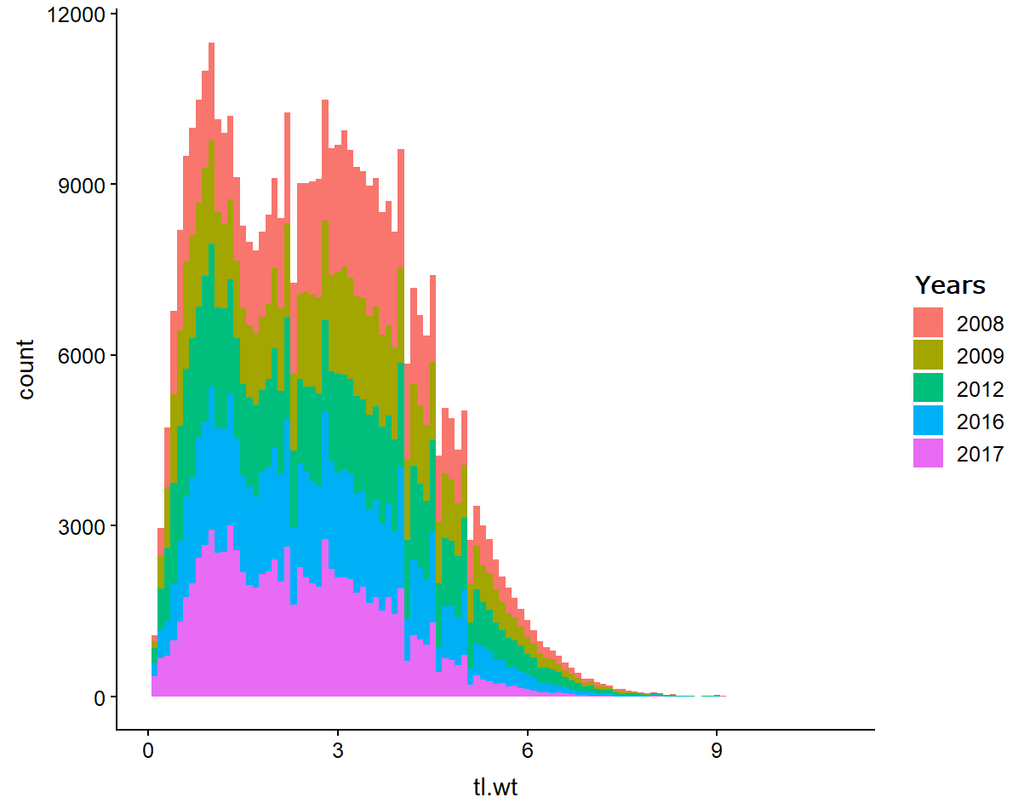

Figure 23. Weight (g) distribution of seabob sampled between January to December (2008-2017).

1. Global seabob landings (2000-2014)

Table 8. Global Capture Production (Tonnes) for Species (FAO, 2017)

|  |  |  |  |
| --- | --- | --- | --- |
| Scientific name | 3Alpha Code | Year | Quantity[t] |
| seabob | BOB | 2016 | Null |
| seabob | BOB | 2015 | Null |
| seabob | BOB | 2014 | 40,073 |
| seabob | BOB | 2013 | 49,217 |
| seabob | BOB | 2012 | 52,651 |
| seabob | BOB | 2011 | 44,564 |
| seabob | BOB | 2010 | 41,716 |
| seabob | BOB | 2009 | 42,001 |
| seabob | BOB | 2008 | 37,014 |
| seabob | BOB | 2007 | 42,397 |
| seabob | BOB | 2006 | 43,139 |
| seabob | BOB | 2005 | 42,686 |
| seabob | BOB | 2004 | 39,391 |
| seabob | BOB | 2003 | 46,325 |
| seabob | BOB | 2002 | 43,905 |
| seabob | BOB | 2001 | 50,456 |
| seabob | BOB | 2000 | 40,556 |

1. Length distributions of last haul species by category.

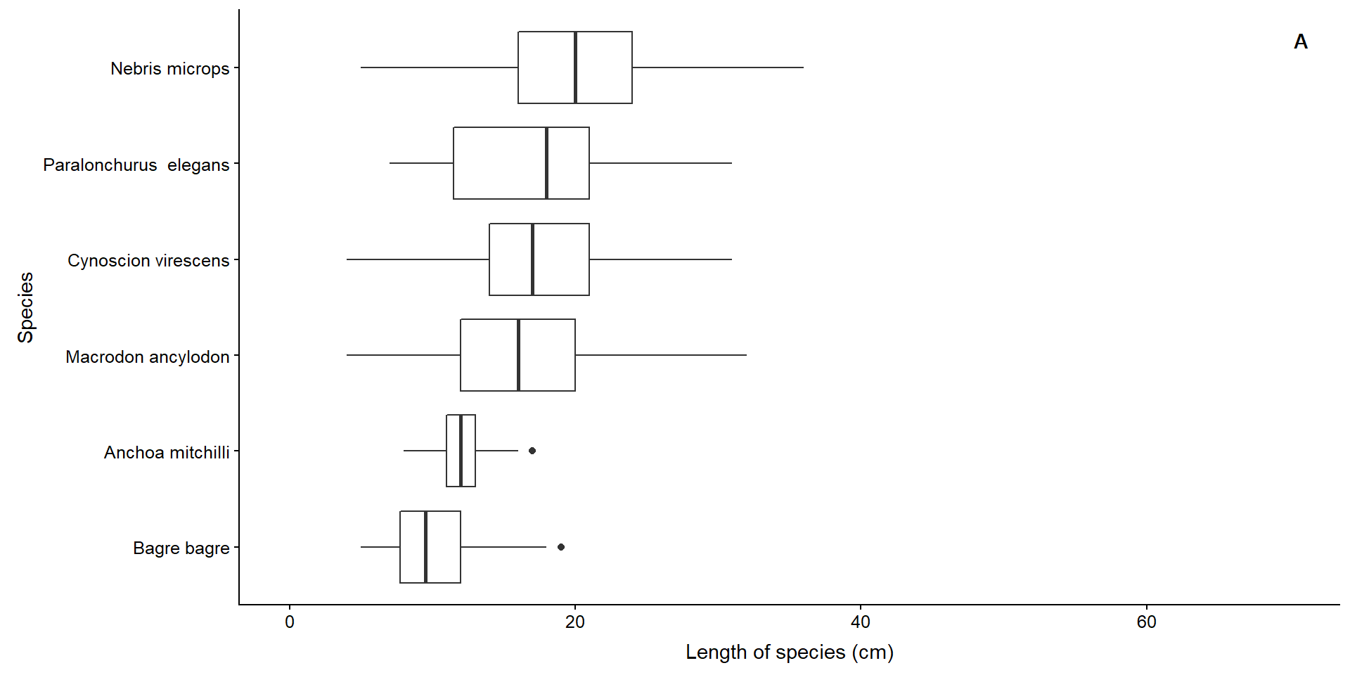

Figure 24. Length (cm) distribution of commercial species most present in sample.

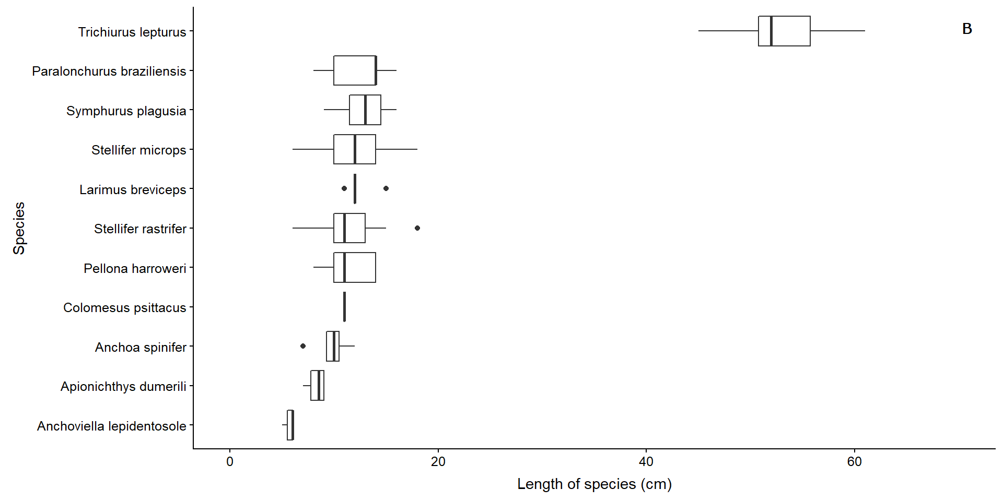

Figure 25. Length (cm) distribution of non-commercial species most present in sample

1. Diagnostic plots from GLM

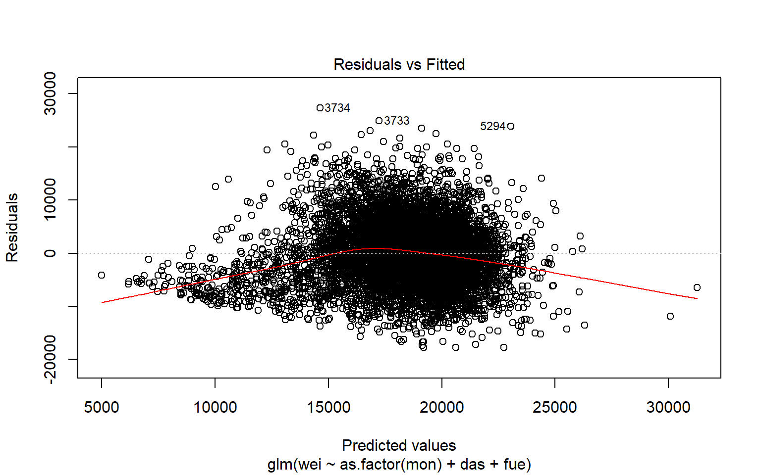 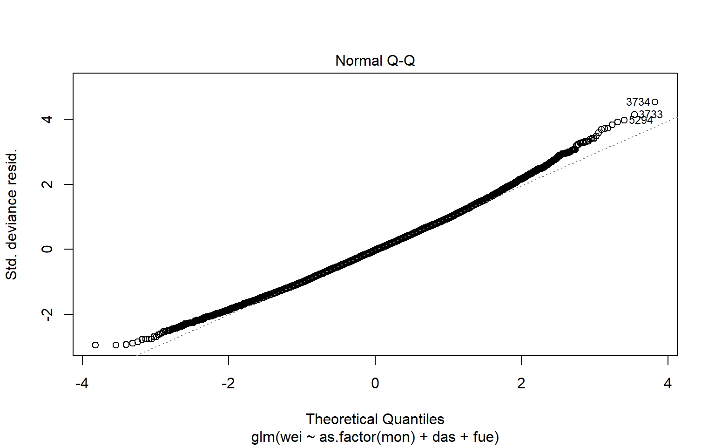

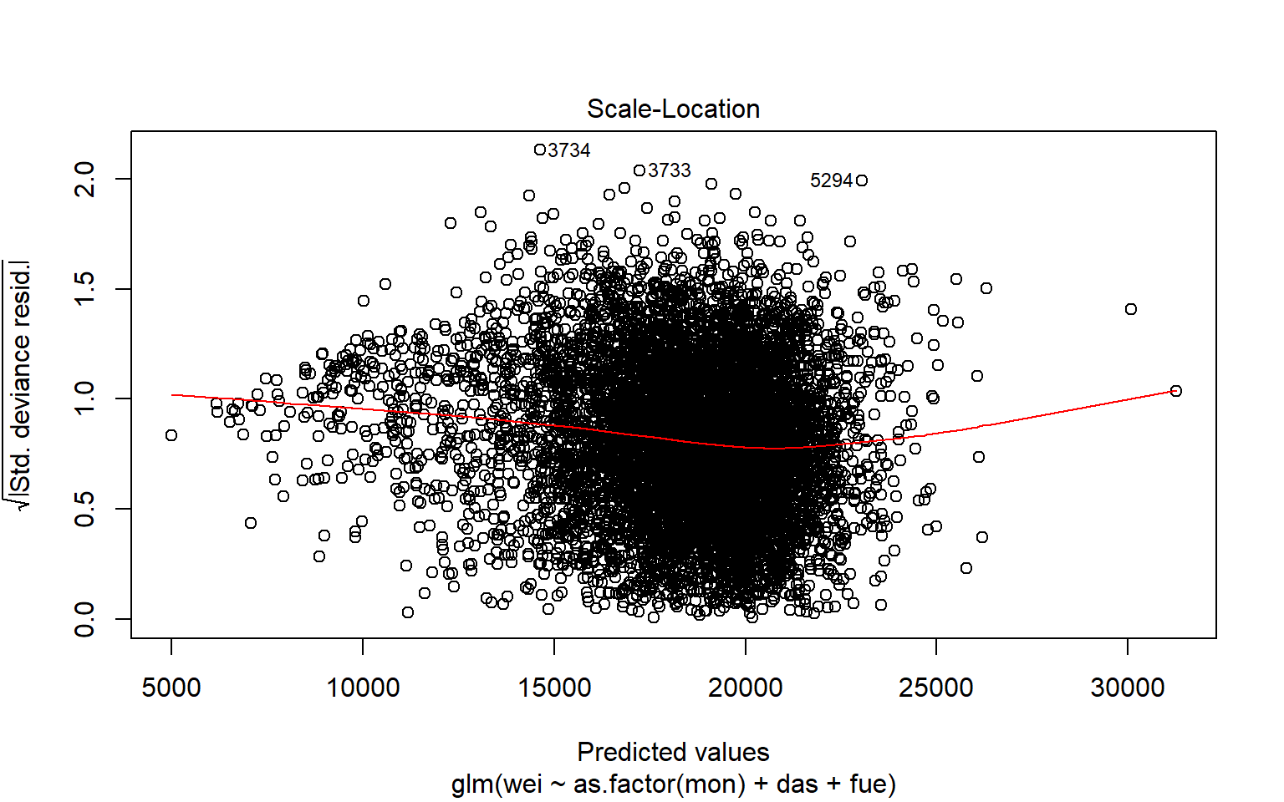 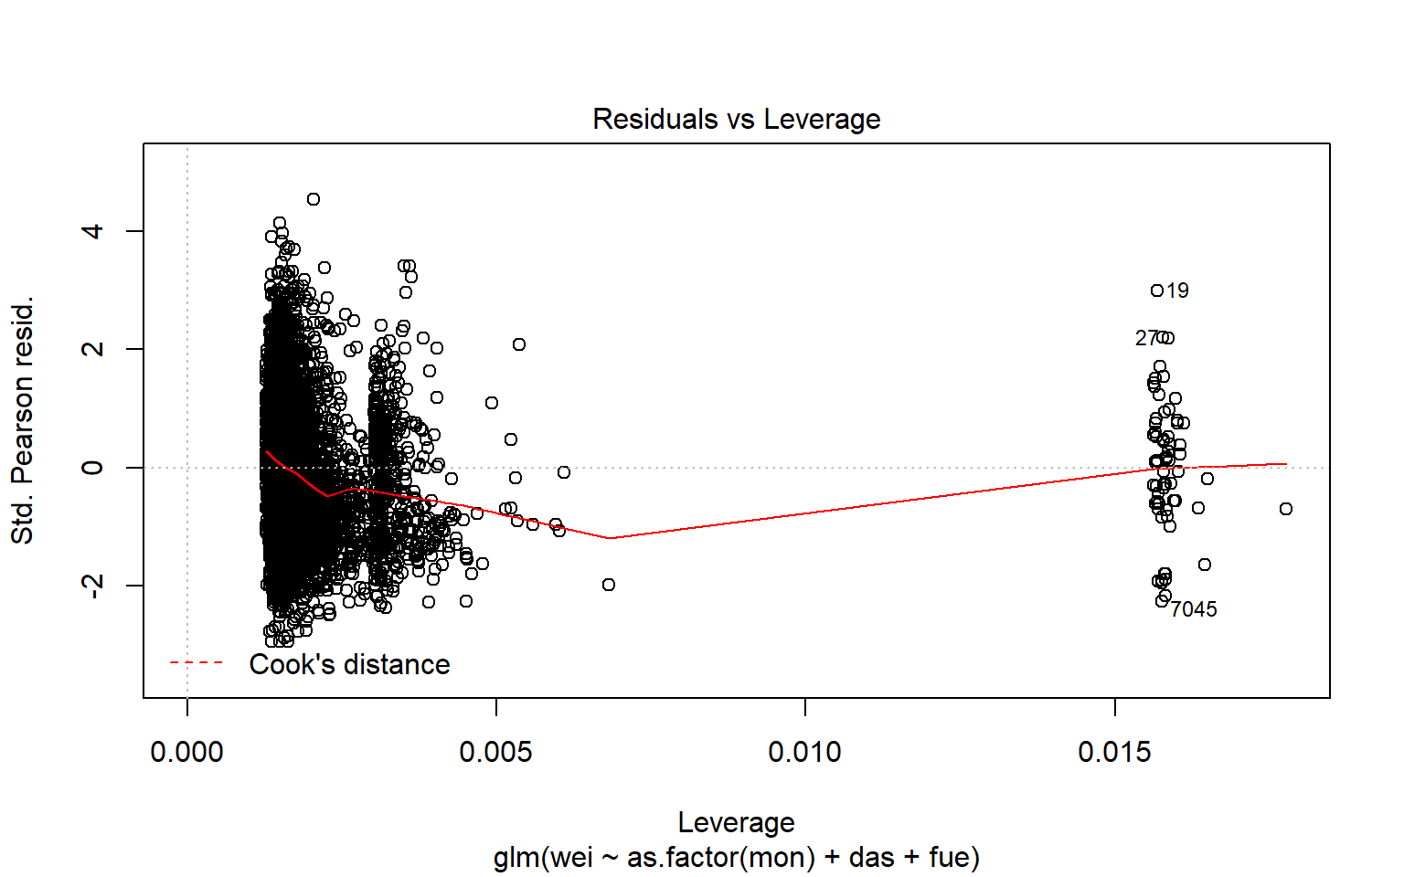

Figure 26. Diagnostic plots (residuals vs. fitted values and cumulative normalized residual plots) from GLM fitted seabob dataset. Factors considered were months, vessels, days at sea and fuel usage. In general, residual patterns are not far from expected under the normal error distribution assumption, which suggests a reasonably good fit.

1. Photos of species sampled in last haul

Commercial species caught in seabob trawls

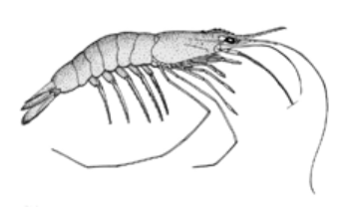 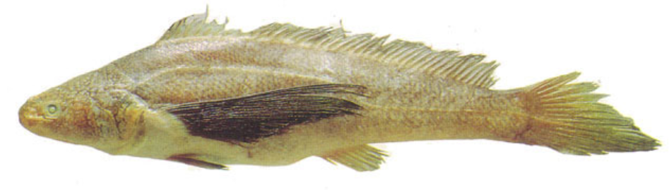

***Xiphopenaeus kroyeri*** ***Paralonchurus elegans***

*Max. length = 11.5 cm Max. length = 32.0 cm*

*Range = 1 - 1.75 cm Common length = 27.0 cm*

*Maturity: Lm 1.4 cm* ***Source:*** *FishBase*

***Source:***(FishBase)

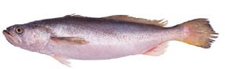 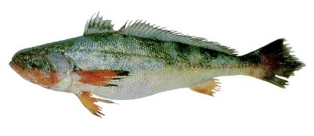

***Macrodon ancylodon*** ***Nebris microps***

*Max. length = 45.0 cm Max. length = 40.0 cm*

*Common length = 35.0 cm Common length = 35.0 cm*

*Range = 18 – 46 cm* ***Source:*** *FishBase*

*Maturity: Lm 23.7 cm*

***Source:*** *FishBase*

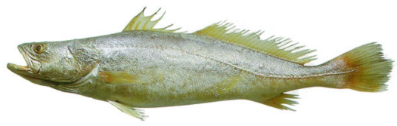 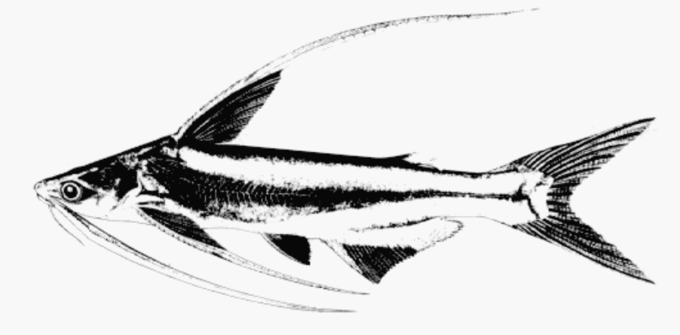

***Cynoscion virescens*** ***Bagre bagre***

*Max. length = 115 cm Max. length = 55.0 cm*

*Common length = 65.0 cm Common length = 40.0 cm*

***Source:*** *FishBase* ***Source:*** *FishBase*

### 

Non-commercial caught in seabob trawls

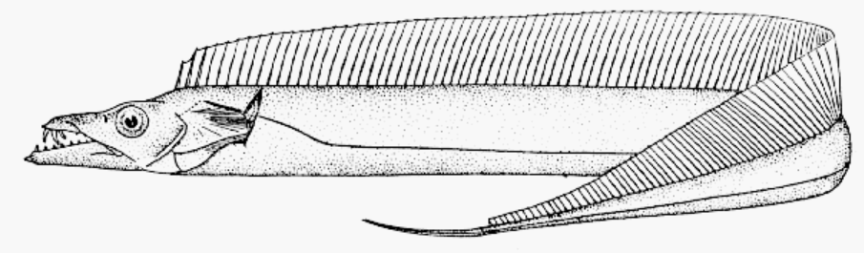 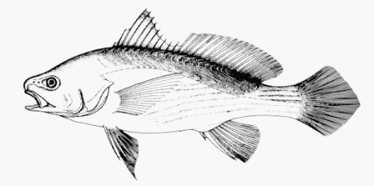

***Trichiurus lepturus*** ***Stellifer microps***

*Max. length = 234.0 cm Max. length = 20.0 cm*

*Common length = 100.0 cm Common length = 12.0 cm*

*Maturity: Lm 50.6 cm* ***Source:*** *FishBase*

***Source:*** *FishBase*

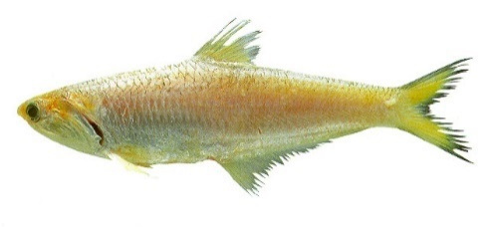 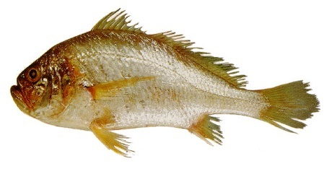

***Anchoa spinifer*** ***Larimus breviceps***

*Max. length = 24.0 cm Max. length = 31.0 cm*

*Common length = 20.0 cm Common length = 20.0 cm*

***Source:*** *FishBase* ***Source:*** *FishBase*

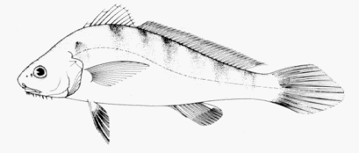 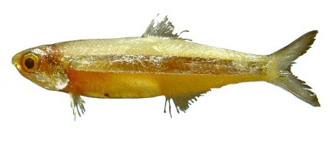

***Paralonchurus braziliensis*** ***Anchoviella lepidentosole***

*Max. length = 30.0 cm Max. length = 16.4 cm*

*Common length = 25.0 cm Common length = 9.0 cm*

***Source:*** *FishBase Range = 7 - ? cm Maturity: Lm 9.4 cm*

***Source:*** *FishBase*

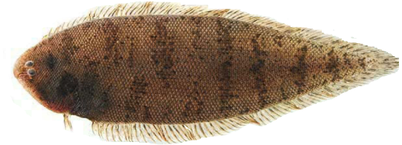 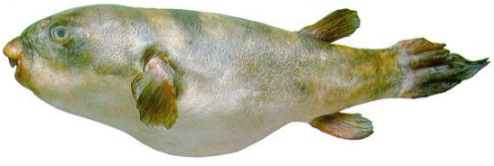

***Symphurus plagusia*** ***Colomesus psittacus***

*Max. length = 25.0 cm Max. length = 29.3 cm*

*Common length = 20.0 cm Common length = 25.0 cm*

***Source:*** *FishBase* ***Source:*** *FishBase*

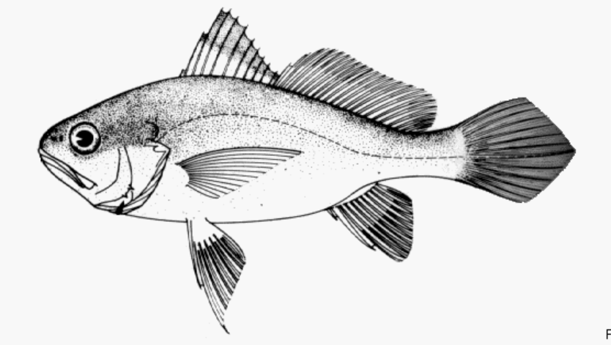

***Stellifer rastrifer***

*Max. length = 32.1 cm*

*Common length = 15.0 cm*

*Range = ? - 16 cm*

*Maturity: Lm 9.8 cm*

***Source:*** *FishBase*

1. See Appendix 3 for landings from 2000 - 2014
2. A usually sinuous line on a nautical chart joining all points having the same depth of water and thereby indicating the contour of the ocean floor (Merriam-Webster dictionary).
3. See detailed procedure in Procedure for adjusting HCR Appendix 1.
4. See boxplots in Appendix 4
5. The most common species in the sample are those which recorded the higher biomass across all last haul trips.